Letter a

### Types

1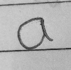

No inner loop

1. No inner loop show open-minded, honest individual. They do open up and communicate with their close people. This is because they feel comfortable at home. Can sit calmly and do things.
2. Extended a, these writers are way more comfortable at home. The reason they are lazy people. Don't take quick action. Unable to get out of their comfort zone.
3. Squeezed a, they do not feel comfortable at home or around their close friends. Unable to sit calmly in one place. Always want to do something, be busy.
4. Broad a or bigger a, spontaneous who like doing things in their way in their home, or comfort zone. Like pleasure and food
5. Extended ends, take a lot of time to open up and are unable to make people love them.

### Gaps

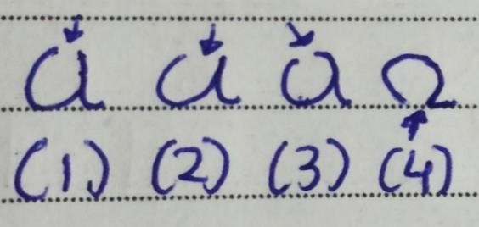

* 1. Small upper gap, talkative person at their home and around close friends. A consistent person who is straightforward and frank whenever they speak with their close ones. Willing to accept new ideas, and thoughts.
  2. Big upper gap, like talking about themselves. They are also frank yet can be manipulated by others.
  3. Left side upper gap, an introverted personality who has insecurity. Reserved, shy people in nature.
  4. Down gap, they don’t trust their close friends, or family members easily without verification. Lack of honesty.

### Inner Loops

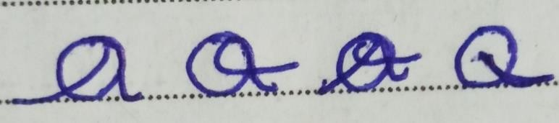

1. Leftside loop, a writer here is trying to fool themselves about their family, and people in their comfort zone. Not accepting real facts.
2. Rightside loop, secretive at home. They don’t give clear answers instead answer questions indirectly at home or around their close friends.
3. Bothside loop, two-faced individual. They want to be liked by others. Rare trait
4. Hooked, they try to avoid commitment and feel guilt. Can be manipulative and may try to change the real facts to manipulate others. Very rare trait.

86

### Other Traits

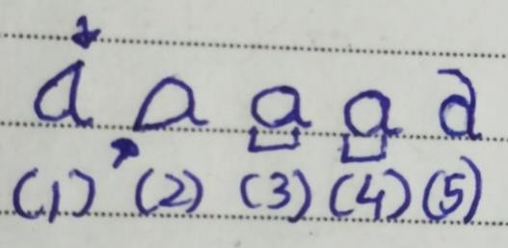

* 1. Angle at the top, they stand up themselves and are determined in nature. They are also someone who seeks revenge.
  2. Angle at the bottom, a writer who gets defensive if someone tells them the right things or gives opinions. Aggressive people who are stubborn and sensitive.
  3. Oval a, kind person who always tries to understand and help others, shows their true self at home, and is clever.
  4. Circle a, react slowly, and are not open or truthful. Unable to relate emotionally.
  5. Font a, try to be as simple and natural as possible. May not show their true self.

Letterb

### Basic Types

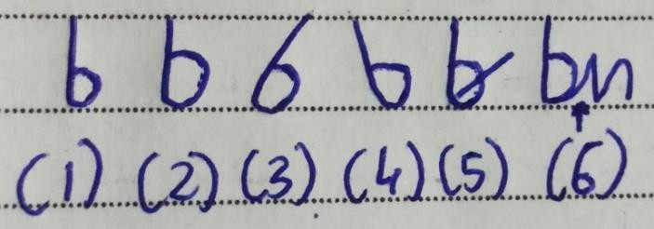

1. Small loop in b, the writer communicates directly instead of trying to extend the conversation. They are satisfied with themselves and have good blood pressure.
2. Big loop, they are also confident in their abilities and can handle stress without depending on others. Balanced outlook towards life. Practical people who have good mental health.
3. Rightward b, more emotionally open and can see situations from a different perspective.
4. Leftward b, family problems, sensitive people in nature who are more motivated by physical expressions of acceptance instead of emotional ones.
5. Line in the middle, stand up for themselves, and don’t like being interrupted in between as they feel low or inferior if someone does it.
6. Connected b to next letter, allrounders who have multiple skills. Focus on the positive side of the situation.
7. Gaps

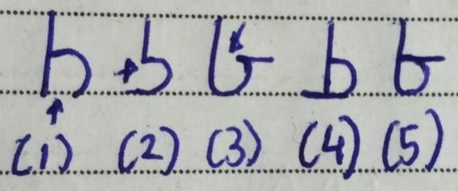

* 1. Gap at the bottom means improvement in health, wealth, and relationship is needed. They don't feel good about themselves and are currently unsatisfied. Have difficulty in finishing tasks. Yet can find trouble in a situation. Irregular blood pressure.
  2. Gap on the left side, these writers have high blood pressure. If someone writes like this then do tell them to check their heart rate. they feel unsatisfied with themselves, their work, or the results they have got. Even when they have received something they want more. Greedy people.
  3. Upper gap, they are satisfied yet not fully. They believe something more could have given them more satisfaction. Have a lack of emotional happiness.
  4. Closed b with extended line on left, they got what they had expected and are feeling satisfied yet still, they want more. Again, greedy people.
  5. Closed b with an upper line, connect emotionally with their dreams, and things they want. Are very clever. Have good business sense.

### Angles

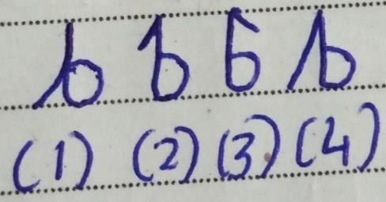

1. Retracted b or very small down angle, instead of trying something new they like to follow what they had done before.
2. Upper left small angle, they value past ideas more when doing something new or when recovering from stress.
3. Upper right small angle, future ideas are given more importance by these writers whenever they are doing something to recover or overcome stress.
4. Long left side angle, feel jealousy and have a habit of focusing on unnecessary things due to which they are unable to do right things.

### Loops

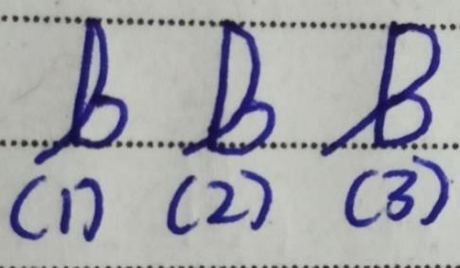

92

* 1. Small Backside loop, they like to focus on multiple options or solutions instead of just focusing on one.
  2. Medium Backside loop, now here writers consider many options instead of two or three they consider many other solutions.
  3. Large Backside loop, they get confused about which option or solution to choose as they consider too many options. Take a lot of time to start taking action and recover.

### Formation

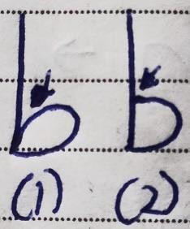

1. Here v formation is present, writers practically use the knowledge they have learned to improve themselves. Have more interest in learning things that are practical, direct on point.

# Letter c

### Formations

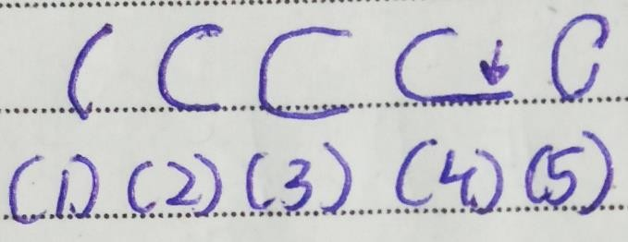

1. Half c, anxious people who are socially very self- conscious. They do not feel comfortable socially and lack confidence. The bigger the gap more the uncomfortable they feel socially. Mostly Introverts.
2. Normal c, these writers feel comfortable socially and mostly are ambiverts or extroverts. Have good social acceptance, and confidence and are frank. If you don't feel comfortable socially then writing "c" like this will help you. The ideal c
3. Longer c, a writer here feels comfortable socially yet are not that serious. They will do things just for the sake of doing them.
4. Down extended c, overthinker who overthinks situations when it’s not needed. They don’t just let go of what had happened socially. Not a good trait.
5. Small gap c, private, reserved people who feel comfortable yet don't open up socially. The reason for this behavior is a lack of trust. The less the gap less the writer opens up socially. Extreme introverts.

### Loops

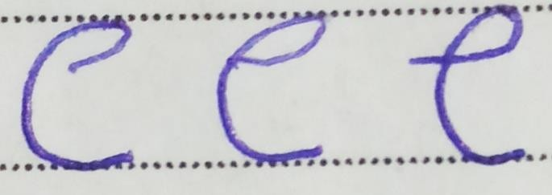

* 1. Half e formation, writers here hold grudges about the social situations which significantly impact their mental and physical health. They are harsh towards the opposite sex.
  2. Letter e formation in letter c, the person who likes culture and traditions.
  3. Letter e formation in letter c with an extra line on left-side, they keep giving opinions about what is wrong and what is right.

### Letter d

### Size

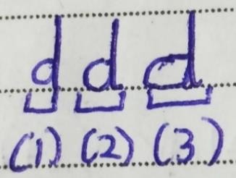

1. Small oval, a writer here is feeling a lot of pain and is suffering. They are feeling incomplete.
2. Medium oval, reserved people with more interest in practical things. They have good common sense
3. Large oval, these people have good business sense.

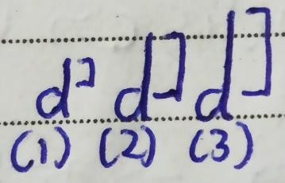

1. Short stem, their physical health needs improvement as they cannot perform heavy physical activities. There is a lack of common sense as well.
2. Long stem, indicates good physical health. They are confident about their physical body. Intellectual people.
3. Very long stem, very intellectual due to which they may overthink a lot.

### Loops

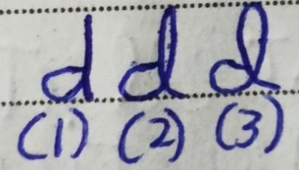

* 1. No loop, the writer doesn’t react much when being criticized about their physical health or eating habits, or physical appearance.
  2. Small loop, they are sensitive toward criticism. React when someone criticizes them about their physical health or appearance. Reactions could be getting emotional, grudges, anger, motivation, etc. It depends on the writer.
  3. Very big loop, extremely sensitive towards criticism. They react instantly and are very conscious about what they wear and how they look.

### Shapes

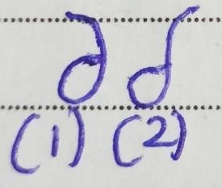

1. Reverse 6 left, writers like different cultures and traditions. They have an interest in good music, poems, and songs.
2. Reverse 6 right, want to inspire others. A good speaker who has an independent spirit. Rare trait.

### Gaps

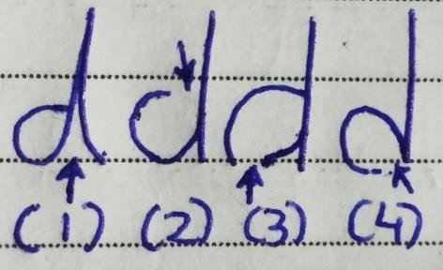

1. Gap between two stems or small down v formation, they like to do what they have been told to do. Don’t break rules. A very big gap v formation shows stubbornness.
2. Upper gap, unable to make good decisions due to lack of judgment. May fall for lies quickly. Have the ability to combine things and create something new. Speak a lot more than what’s necessary.
3. Bottom gap, hypocritic who say doing certain physical exercises or grooming or eating food is not good yet in reality they do those things.
4. Claw Formation, they overdo things that damage their physical appearance and health. A workaholic who goes to extremes be it work, exercise, or addiction. Like outside food.

### Strokes

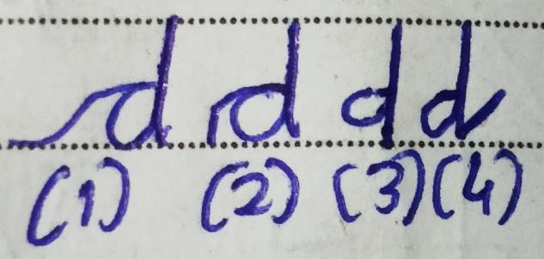

* 1. Leftward long extended start stroke, aggressive people in nature who have a good set of values and principles about what to wear, exercise, eat, etc.
  2. Leftward short extended start stroke, physically well balanced. They have control over their physical self and are rational people who take logical decisions.
  3. Downstroke, impulsive who quickly acts without thinking or giving it a thought.
  4. Leftside angle or stroke, they don’t like to do what authority is telling them to do. Like to go against them. They may get aggressive when it’s not needed.

# Letter e

### Loops in e

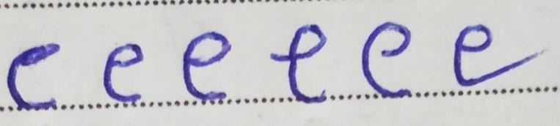

1. No loop in e, these writers are bad listeners. They are not open to new ideas, and people and that is the reason they don’t change easily.
2. Medium loop, at the start they do listen yet as the conversation goes by, they lose interest and start thinking about other things. They will not accept what others are saying without validation.
3. Big loop, kind people in nature who are very good listeners. They are open to new people, and ideas. Will change it if it’s needed. Stay calm in tough situations and express things in a good manner. Ideal
4. Line outside c, argumentative person who argues with others while or after listening. They question other people’s opinions. Journalists write like this.
5. Incomplete e-loop, a good listener as a loop is big yet they have a problem relating with other people’s opinions, and thoughts.
6. Extra e, a writer here is facing a dehydration problem and needs to drink more water. Now since the end is sharp writer feels irritated and is not satisfied. No loop with a sharp end shows extreme frustration.

Letter f

### Loops

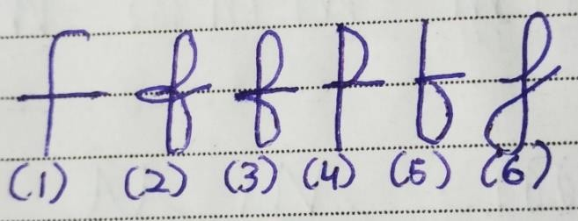

* 1. No loops,writers have average planning and execution ability. They may plan things yet it may not be in detail. The same is their execution.
  2. Upper, Lower loop and loop in middle, persistence. The writer doesn’t give up and keeps going even after multiple failures in their planning, and execution. Because of this attitude, they can achieve great things. They are organized in nature as well. Many successful entrepreneurs and top people write like this.
  3. Upper, Lower loop, organized people in nature who plan first and then start executing instead of directly executing or just planning. Many managers write f like this.
  4. Only upper loop, a writer is a planner who thinks and writes down the plans. Yet they don’t execute their plans and completing projects becomes hard for them. A career that requires only planning like receptionist, call center, etc. is good for them.
  5. Only lower loop, an executor who plans less and executes more. Due to this they may get half result or start unnecessary projects which don’t need to be done. They want to get things done as fast as possible the reason they are writing like this.
  6. Down loop on the left side and upper loop, they have a smooth flow of thoughts and give opinions calmly. Have more attachment towards their mother’s native place as during childhood days they may have stayed there a lot. They have good speaking skills and can be a good public speaker, and writer.

### Size

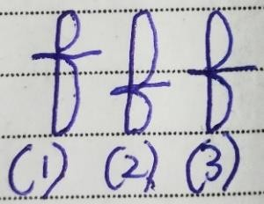

1. Upper loop is very small, a lower loop is bigger, and these writers plan less and execute more. So, they do plan yet the execution is given more importance.
2. Lower loop small, upper loop bigger, they plan a lot yet execute less. Out of 10 planned ideas, they execute 3 ideas.

Same-size upper and lower loops, give equal importance to planning and execution and that is the reason they can be more organized and get results.

# Letter g

### Loop Formations

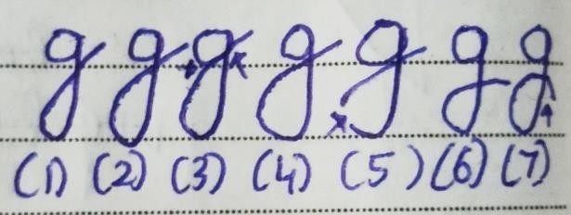

1. Small loop, they spend very less money on their home finances which could be painting the house, furniture, renovation, etc. Very less social.
2. Medium loop, they are social yet are comfortable being alone as well. They spend money yet it’s not too high. Mostly buy things that are needed instead of just buying everything they want. Like to do new things instead of staying in the same old money patterns.
3. Loop touching the upper a or circle, poor money management at home. Conflict happens with family related to it. They may not be able to pay bills on time.
4. Very big loop, materialistic people in nature who spend a lot of money in buying things for home or family which are not needed.
5. Broken loop, the writers here have faced some loss in home investments. Lower body health problem. Rare Trait.
6. Loop not reaching upper baseline, just like y here too writer doesn’t trust others easily due to past. Do not give money for home finances unless they trust.
7. Downward loop, fear of success as seen in y as well. Writers fear they may not get successful if they buy something for their home or family.

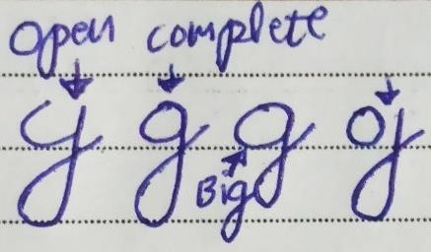

1. Open top, the writer is unable to keep confidentiality about their home finances. So if they buy something then they will tell others about it. They are generous as well. Bigger the gap more the talkative.
2. Complete top, the writer is reserved about their home finances. They don’t just talk about what they have bought for their home or family.
3. Big Size upper a or o and small size loop, there is a lack of sexual life. They do want to buy good things for their home yet are not doing it for some reason.
4. Gap between o and the loop, they feel disconnected from their home finances. Yet look at other traits as well for confirmation.

### Angles

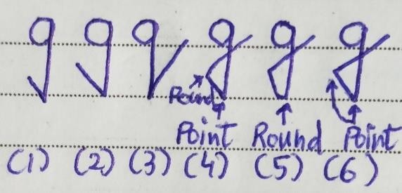

1. Small angle left, do not communicate about their past home finances like the things they bought in past. Get aggressive if one tries to communicate with them about it.
2. Long angle left, Don’t like communicating about their past home finances and if one tries then it leads to violence.
3. Long angle right, right shows the future so here writer gets aggressive if one tries talking to them about what they are going to buy in the future for their home. Big gap show violence.
4. Pointed bottom and rounded loop, they like rough or hard sex. The same is applied to letters y, and j if the same loop formation is there. Other than that they don’t have the softness and can be impulsive when buying something for the home.
5. Rounded bottom and pointed loop, they force themselves to not think about sex, buying something for the home. Less social.

108

1. Pointed bottom and loop, impatient who wants to do things as quickly as possible. They will buy things for the home, and family quickly without giving much thought. Their libido or sex drive may be interrupted due to health problems. No triangle formation in the letters y, g, and j is good. Avoid it!

### Directions

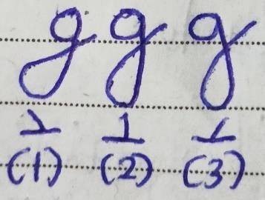

1. Leftside, does not focus on logic or emotions when buying something, they do it for just the sake of doing it. Focus on past buying decisions. Can adjust with others in a good manner. Very rare trait.
2. Straight, have self-control over feelings. Make logical buying decisions instead of emotional ones. Common trait.
3. Right, more of an emotional person who makes emotional decisions when they buy something for home or family. Very rare trait.

### Other Types

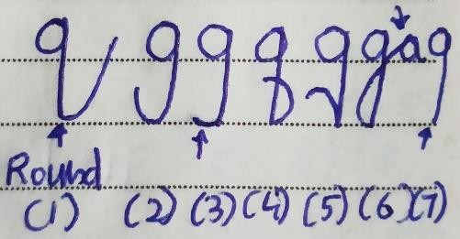

1. Rounded bottom and left side angle, a very nice person whom other people may take advantage of.
2. Half loop, possessive people in nature who are frustrated about their home finances.
3. Leftside curve, stuck in the past as the loop is not completing and is on the left side. They repeat the same life mistakes/lessons over and over be it about relationship patterns or home finance issues, etc. Have problems completing tasks.
4. Loop from right to left, selfish people who focus on buying things that can only help them or make them feel good.
5. Claw, family issues as well as home finances issues. They try to hurt themselves.
6. Connection to next letter, satisfied with what they got and about their home finances. Feeling fulfilled.
7. No loop, they know how to dress, and look well. Have problems connecting with family or close people.

Letter h

### Formations

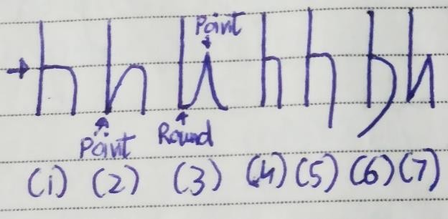

* 1. No v formation, a writer is having more interest in learning things which are theoretical. While expressing too they teach or express concepts that are theoretical and cannot be applied practically. They like to follow rules and then solve a problem, and teach something. Like working in 1 domain.
  2. There is v formation, they are practical people in nature who like to break rules, and think out of the box when solving a problem. Express the knowledge which can be applied practically. They are direct and on point and don’t like adding unnecessary words, or steps in between. Like working in 1 domain same as 1st h.
  3. Rounded bottom and angle at the top, misunderstanding happens with the communication. Learners understand something different or get a different message than what the writer is trying to express. Unable to express their knowledge effectively.
  4. Narrow h, they don’t share their complete knowledge instead share half knowledge.
  5. Down stroke, want more recognition, money, or something in return than what they teach. So they give less and want more from others.
  6. Left side stroke, they also want more than what they give yet are willing to compromise. Very rare.
  7. Angle bottom and top, aggressive and fast in expression. They like to teach things as quickly as possible. You may see them speaking, and writing in a fast manner.

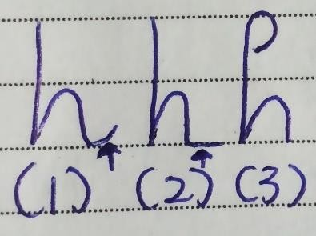

1. Upward end stroke, like helping others improve. They don’t just express themselves for their ego or money or recognition instead they are doing it to honestly help other people in some way.
2. Straight end strokes, express a lot more than what’s needed. Keep repeating a concept instead of finishing and moving to the next.

114

1. Upper incomplete circle, have pleasure-loving nature. They only express themselves if they get some pleasure. Rare Trait.

### Loops

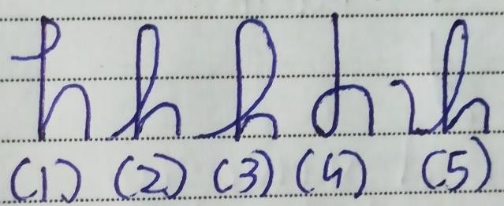

1. Small loop at the top, broadminded individuals who respect other people’s opinions even if they are opposite which is why they have a good relationship with others. They have an interest in many domains and express what they had learned creatively.
2. Long loop medium size, they have many ideas to express what they had learned. So they may express themselves by writing it, creating a video, speaking about it, etc.

3,Long very big loop, too many ideas are there due to which they get confused about how to express what they know.

1. Loop on the left side, they are also creative while teaching something yet can complicate simple things.
2. Left side curve with long loop, Carry more than what’s essential when expressing. Very rare trait.

### Angles

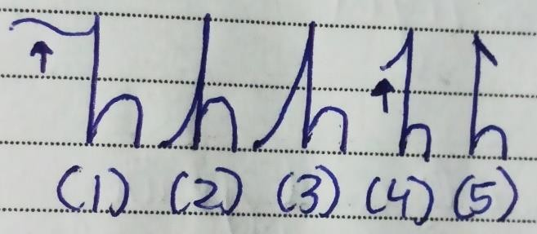

1. Wavy left side upper curve, have difficulty in sharing what they had learned. Don’t like being compared about how they teach. Good sense of humor.
2. Retracted h or short angle, instead of teaching or expressing in a new way they keep doing things in the same old way. Take time to change.
3. Long angle, these writers too don’t like trying new things and keep doing the same things again and again. Unwilling to change, stubborn.
4. Short left side angle when solving a problem or expressing something they look at in the past.
5. Short right side angle, more future-focused. Before learning or expressing they think if it will help them in the future or not.

# Letter i

### Placement Of Dots

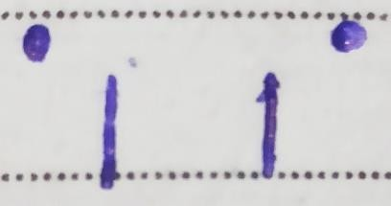

1. Left side dot shows procrastination. These writers don’t do work on time. They also lack courage and think about past.
2. Right side dot, a writer is impatience and wants to move further as fast as possible. Ambitious

individuals who are future-oriented. Curious people who like finding new things.

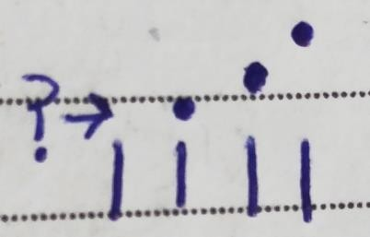

* 1. No dot means a writer is not organized about their personal life as they are careless. It is also a sign of depression.
  2. Dot right above the bar, detail-oriented people who are organized about their personal life. They have good concentration and a calm attitude. Can do good in a career that requires focus.
  3. Normal height dot, detail-oriented as well as imaginative.
  4. Very high dot, good imagination, and creativity. Daydreamers who sometimes lose contact with reality. The reason they don’t have good concentration or focus. A career that requires innovation, and creativity is right for them.

### Different Types Of Dots

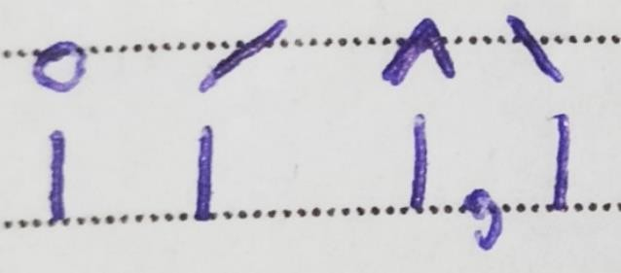

1. Bubble dot writers are very creative yet they have childlike behavior. Immature, smiling face, very curious. It is a feminine trait that most girls have yet if a boy is having this trait, then he is having feminine interests like love stories, etc. Commonly found traits in many handwritings. Bubbly personality.
2. Rightward line, they are witty.Irritation towards others.
3. Tent or Left side line, writers here are intellectuals who have an interest in understanding complicated things. These writers question, analyze, interpret, evaluate and make a judgment about things they learn, read, hear, say, or write. Irritation towards self.

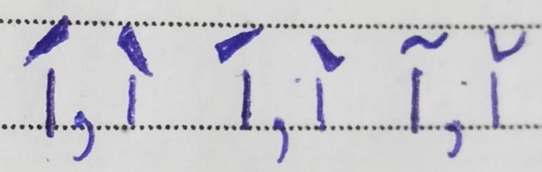

3. Curves, a writer here has a good sense of humor and is attractively energetic, and enthusiastic.

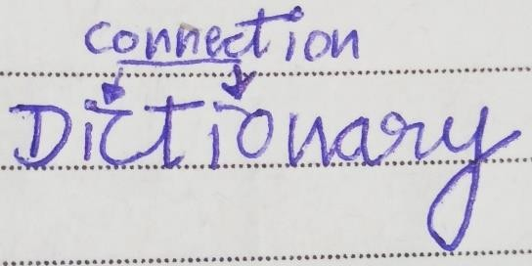

Their mind works faster than their hand the reason they are unable to lift the pen after making the dot.

They are fast learners, intelligent, and dynamic.

### Different Shapes

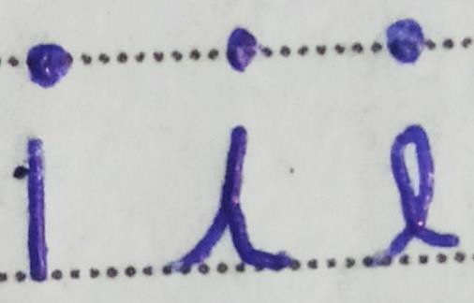

1. Straight line, writers here are direct.
2. V formation, these writers show respect and are polite. They give before receiving things from others.
3. Loop, like helping others and focusing on emotions. Also, try to understand other people in a better and more creative manner.

Letter j

### Loops

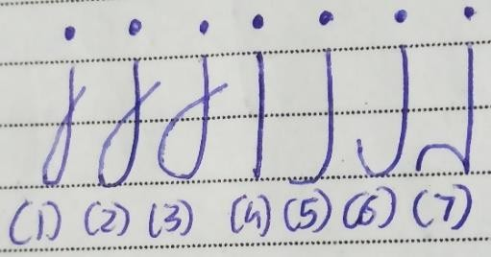

* 1. Very small loop, the writer is very selective about what they are buying for themselves and that is the reason they don’t buy many things.
  2. Medium loop, writer buys things for himself/herself which are needed. So they don’t spend money on unnecessary expenses. Balanced self-finances. They also like sharing what they bought with others and also like giving back. Make long-term investments.
  3. Big loop, now bigger the loop more the writer spends on themselves. They buy things that are not needed. Materialistic in nature.
  4. No loop, a lonely person as we have seen in the letter y as well. Writers here only buy for themselves and don’t like sharing with others. Eg - They will only wear the dress they bought and will not share it with their friends.
  5. Left side curve, they repeat old money patterns due to which they buy things that in past were not good.
  6. Incomplete loop, look at past experiences and mistakes when buying something for themselves yet they also share things they bought with others.
  7. Small claw, they buy a lot of things at a time than what’s needed. They buy a dress and shoes at the same time when only buying a dress was needed.

### Dots Position

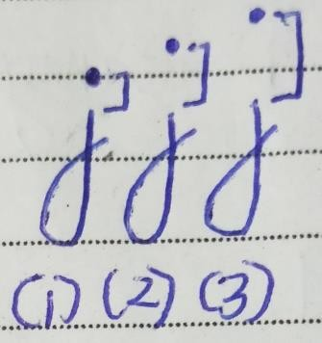

1. Dot right above, a detail-oriented person who focuses on small details when buying things. Have the patience to wait before making the decision.
2. Dot a little upward, they don’t have the patience to wait before buying things for themselves. Instead of detail, they focus more on their imagination. If a product looks just like they were dreaming about then they buy it.
3. Very high dot, dreamy people who dream a lot due to which they get confused about what to buy as they have unrealistic expectations.

120

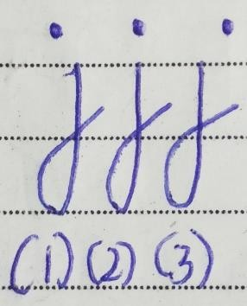

* 1. Leftside, they procrastinate a lot before buying things that are needed.
  2. Dot in middle, they focus on the present and on what needs to be bought now. They don’t procrastinate.
  3. Dot on the right side, future-oriented who are very impatient. They buy things quickly.

### Types Of Dots

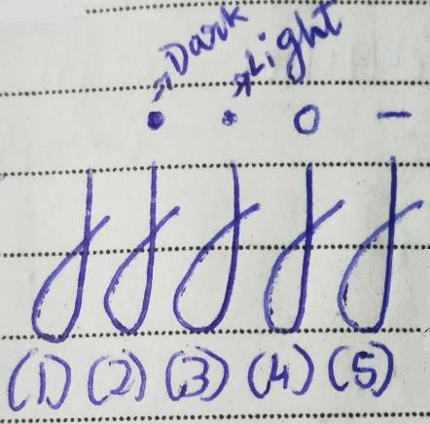

1. No dot, careless individuals who would buy anything without thinking about it.
2. Dark dot, have good memory and passion. They are serious about what they are purchasing. Have good energy levels as well.
3. Light dot, there is a lack of willpower due to which they don’t feel confident about what they are buying. Low energy levels, depressed.
4. Bubble dot, childish behavior, and immaturity. Sometimes they may pay more than what could have been less. In j this formation is rarely found.

Line, writers here are feeling anxious about what to buy for themselves. It could be due to self-doubt.

# Letter k

### Angles

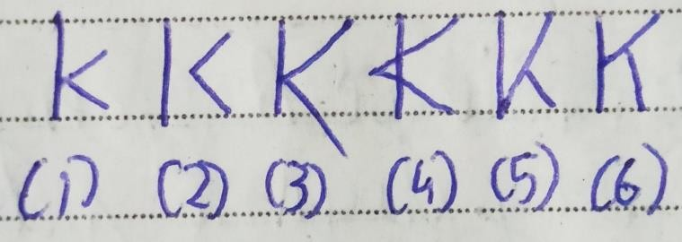

* 1. Ideal k, writers who write like this can maintain a long-term relationship. They are witty and dramatically express their romantic feelings and emotions. Their creativity is easy to understand.
  2. Gap in k, have a problem in maintaining long-term relationships as they get irritated with their partner and have problems with commitments. Another person is unable to understand their creativity or expression.
  3. Down the bottom line, they are more physical when it comes to relationships. So they like to touch other people. Hug them or show their love and they feel understood if another person is doing the same.
  4. Joined lines on the left side, less witty. They are desperate as well due to which they try to force or convince other people about what they had done.

5.V formation and angle, they are analytical and don’t show many emotions when expressing their romantic feelings or creativity. They don’t marry against their parent's wishes. Arranged Marriage.

6.V formation in the middle stem, they are trying to control their romantic feelings instead of expressing them fully.

### Loops

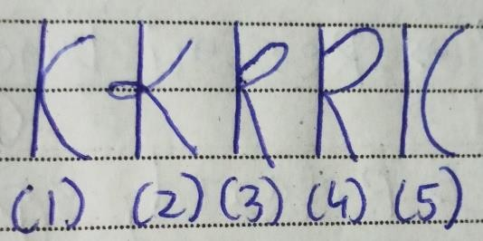

1. Instead of an angle, a round curve is present, a writer is very romantic and understands the other person and then expresses their romantic feelings. They are not analytical and may take some time to express their feelings.
2. Loop on the left side or in middle, a complicated expression they so they do want to express yet are confused about how to do it. The bigger the loop more the confused a writer is. Unable to understand wittiness or humor.
3. Go to hell K or small buckle k, a writer who likes freedom and doesn’t like being controlled by others. Can be seen in teenagers’ handwriting as they don’t like listening to parents or authority. Some entrepreneurs too write like this as they want to be the ones in control. They like to gain some experience and then express their creativity or feelings.

126

1. Bigger buckle, very rebellious who don’t listen as well as don’t give respect to authority or other people. They seek revenge as well.
2. Gap between stem and curve, they try to understand another person yet are unable to express their feelings as they take a lot of time and are not clear.

### Extra

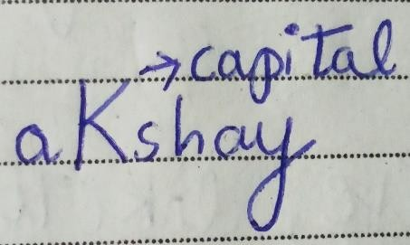

Small letter k written as Capital K, they show anger without any reason. Throw tantrums.

# Letter l

### Loop Formation

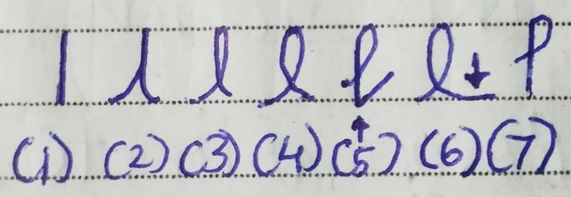

1. No loop, these writers quickly convert thoughts into actions. They are blunt or direct as well and are practical.
2. No loop retracted, these writers are feeling less hopeful about the future. It could be due to some past incident. Many people start writing like this when they lost a loved one or have failed in achieving their goal or dream.
3. Very small loop, they do want to fully convert thoughts into actions yet are restricting themselves from doing so. They take few actions instead of taking full actions.
4. Medium-size loop, writers here take some time to convert thoughts into actions yet they tend to do it creatively. They are relaxed and like to do things in their way. Have big dreams, and hopes for the future. Many good speakers or conversationalists write like this. Bigger the loop more the hopeful they are yet too big a looping show unrealistic hope.
5. Angle at the bottom and half loop, they have uncompromising nature. Rare trait.

130

1. Extra extended, procrastinators who know taking action are important yet still keep procrastinating.
2. Half-complete loop, have a problem in trusting others and like to relax a lot due to which they become lazy and don’t take quick actions.

### Top

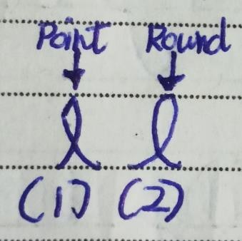

1. Pointed top, they don’t convert thoughts into actions unless they become sure about the result. They are analytical as the angle is present.
2. Rounded top, creatively take action, and open- minded. They are not analytical.

### Other

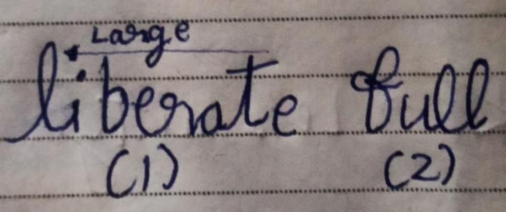

1. Letter l is larger than all other letters, they push themselves too much than what’s needed. Their health suffers due to that.
2. Connect loop l with other letters in middle, they are flexible people who can think while taking action. So if one action needs change then they quickly do it.

# Letter m

### Formations

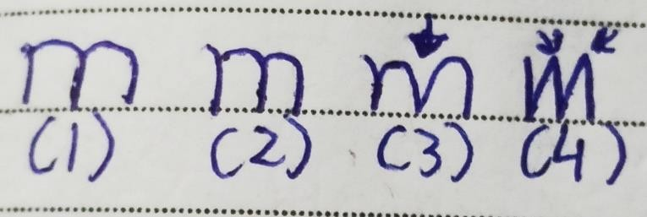

* 1. Rounded and Extended m, these writers are soft- hearted so they may get hurt quickly. Now they also research a lot before making decisions.
  2. Normal-rounded, writers here take a lot of time to learn new things yet once learned they remember it for a longer time. Good long-term memory. These people too research or take some time before taking decisions. Good with their hands so can create amazing paintings, sculptures, etc. They follow rules and then form habits.
  3. Rounded yet the gap in the middle; they are also slow while forming habits or learning things as a rounded top is present yet they like to break rules and do things in their way when forming a habit. If a gap is present in pointed top m then they create fast habits along with breaking rules.
  4. Pointed m, most common m found in leaders, and authorities. They are fast learners and take quick decisions. Have the ability to solve problems, puzzles, and riddles quickly. Analytical people who quickly form new habits. These people are always in a hurry as they like to get things done as fast as possible. Aggressive, good short-term memory. Study one day before the exam & get good marks.

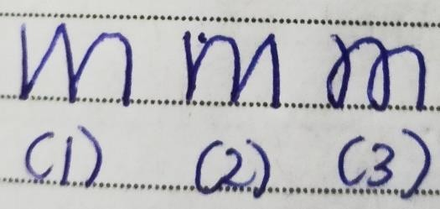

1. Angle at start & round at last, when forming a habit or learning something they are very analytical and fast at the start yet after some time they become slow and calm.
2. Round at start, the angle, at last, these writers start calmly and slowly when forming habits yet after some time become analytical and fast in their action.
3. Loop in m, confused people in nature who have a problem learning and creating new habits. They complicate things that are simple and keep giving excuses for lack of work and consistency.

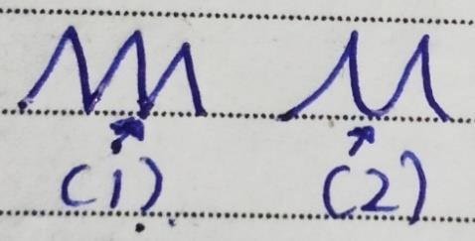

* 1. Garland Pointed bottom, adaptive people who can relate to others in a good way.
  2. Garland Rounded bottom, manipulative people who have a problem managing the habit.

# Letter n

### Formations

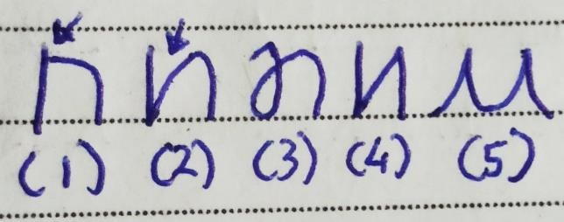

1.No angle in rounded n, writers here follow rules whenever they are doing some new activity which is not a habit. For eg – When going to movies they will buy tickets by standing in line, and following the guidelines.

1. Angle in rounded n, writers take time to decide what to do, and once decided they break the rules and get it done. For eg – They will try to buy tickets from websites or other sources, and will try to get in the middle of the line.
2. Loop in n, confused about what to do exactly. They will keep thinking should I go to a movie? Have a problem doing new occasional activities.
3. Angle, analytical about the new occasional things they are going to do yet as compared to rounded n they make quick decisions.
4. Garland rounded bottom n, unable to express what they had done. Eg – I just watched the movie and it was good I think…no no I think it was not that good.

# Letter o

### Size Without Inner Loops

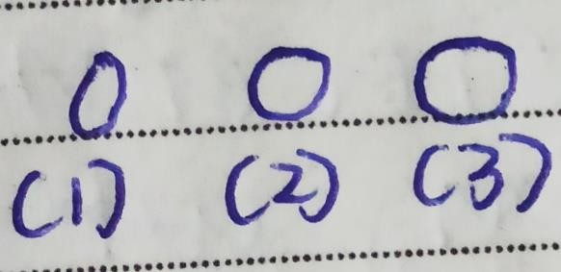

* 1. Small size o, these writers are shy and reserved. They are open minded yet don’t just start talking with others.
  2. Medium, shows an open-minded personality. They are straightforward and say things as they are. If someone wants a genuine opinion about something then these are the right people to ask. Honest people who have good digestion.
  3. Bigger o, a writer here is broadminded so when talking they don’t just speak badly about other people’s opposite opinions. They like showing off and are generous as well.

### Unusual Shape

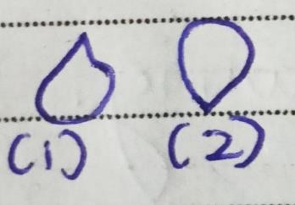

1. They are lazy and don’t move a lot due to which they have slow digestion. Don’t chew food properly. When talking they like being in control.
2. Energy levels are low. They try forcing others to do something they want.

### Gaps

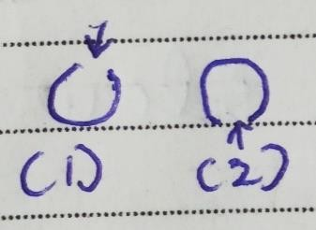

1. Upper gap, talkative people in nature as here mouths look open. They want more of what they already have.
2. Down gap, hypocrite person so their behavior is different from what they say they believe. They say they don’t like junk food yet in reality they like it.

60

### Loops

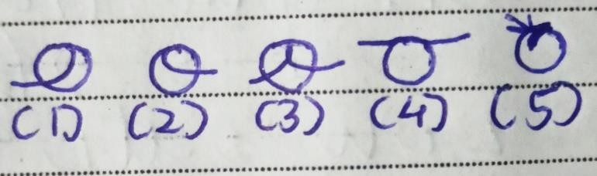

* 1. Leftside inner loop show self-deceit, these writers refuse to face facts and believe something about the self that is not true just because the truth is unpleasant. They keep questioning themselves due to past incidents and try to run away from real facts, and situations.
  2. Rightside inner loop, secretive people in nature who don’t fully open up. The bigger the loop more the secretive a writer is. They also avoid commitment and respond to questions indirectly instead of responding in a direct, straightforward way.
  3. Both side inner loop, question themselves about the past as well as the future instead of living in present. A liar who cannot be easily trusted.Very rare trait
  4. Connected with left and right-side letters, feel satisfied with what they have even if some things are not good.
  5. Small line inside, a writer here is worrying excessively about their health and has self-doubts, and anxiety.

# Letter p

### Formations

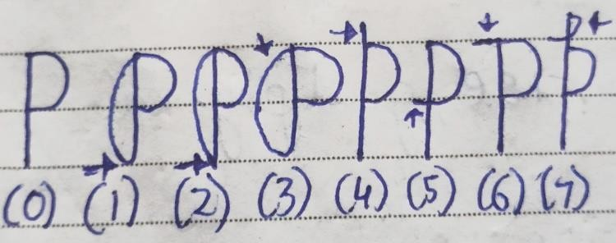

* 1. No loop, good physical health, and capabilities. Internal body health is good as well. Whatever exercise or movement they are doing is helping them in becoming physically more capable. They can quickly react physically when it's needed. Active people.
  2. Rounded bottom loop, these writers are very active be it in sports, sex, moving, or any physical activity. Many athletes write like this. It also shows good physical capabilities.
  3. Pointed bottom loop, they overexercise or push themselves too much than what’s needed which is damaging their physical capabilities, and health.
  4. Very large loop pointed/rounded bottom, no matter which bottom type, writers here are having a lot of energy than what’s needed. They may feel restless. Over energy is not good so always keep the loop size balanced.
  5. Upper extended stem, helpful people who like helping others physically. They are more aware of

what they are doing physically yet may not be quick to react.

* 1. Leftside extended bottom curve, very restless people. Their internal body takes a lot of time to calm down after doing physical activity. After running they still keep taking high breaths for more time than what’s normal.
  2. Leftside extended upper curve, at the start of the physical activity, their body is unable to be calm or balanced. Before running they keep taking high breaths.
  3. Upper loop, more spiritual. They like to do physical and spiritual activities.

### Gaps

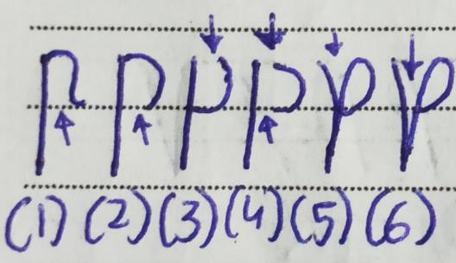

1. Gap with curve or arch, have a habit of picking things physically which are not of them. There is also a lack of finishing energy. Rare trait.
2. Gap at the bottom, at the start they have energy yet at the end they lose it and are unable to finish with

136

the same start energy. Health needs improvement. Quickly start running at a fast speed yet slow down as they keep going.

1. Gap at the top, here it’s the opposite as at the start they don’t have that physical capacity to quickly react yet once started they get that energy. While running they are unable to quickly pick the pace yet they increase their speed once they get momentum or keep going.
2. Gap in both top and bottom, have a problem in overall body coordination. Eg- Hand and eye movement are unable to coordinate. There is a physical health issue.
3. Short v formation, they are aggressive where it's not needed. If you criticize them then they start arguing with you. Stubborn, anxious people who are also physically impulsive.
4. Long v formation, very stubborn and argumentative people who don’t like being criticized about their physical capacities. They react physically or start arguing if one does so.

### Size

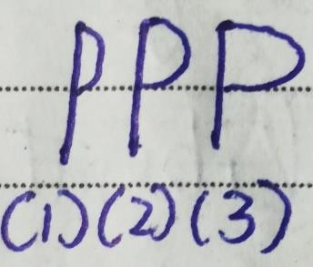

1. Very small p curve, these writers have less energy and there could be an internal organ problem. Need to improve physical abilities as are not able to react quickly.
2. Medium size p curve, writer is having healthy energy levels. Internal organs are good.
3. Very big curve, the writer is having a lot of energy yet is not using it which is getting wasted. Remember more of something is not good.

# Letter q

### Formations

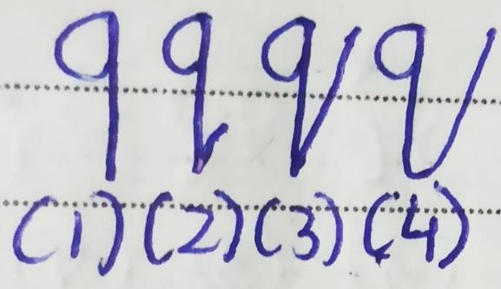

* 1. No loop, writers here lack aggression due to which they are unable to stand up for themselves when someone treats them in a wrong way.
  2. Small-angle, they are someone who shows anger for no reason. People see them as angry people.

1. Large angle with pointed bottom, shows anger at the right place and stands up for themselves when it’s needed. Can say NO to others and don’t let others take advantage of them.
2. Large angle with rounded bottom, they are aggressive yet are unable to show aggression at right time. People take advantage of them and later they feel anger. Cannot say NO to others. The nice guy/girl.

### Long Angle Distance

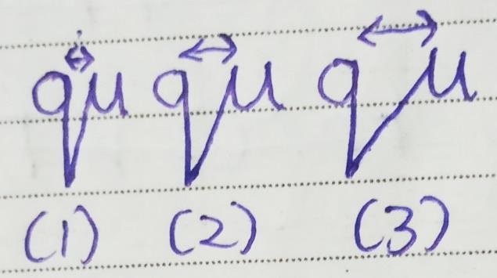

1. Small distance, they show aggression at right time and calm down instead of increasing the argument. Have control over their anger and physical aggression.
2. Medium distance, along with aggression they show ego as well. They keep arguing about who they are when it’s not needed. Have less control over their anger.
3. Large distance, lot of egos as well as anger which lead to violence. They get physically violent in small situations. No control over ego, verbal and physical anger. Avoid this trait.

Letter r

Loops

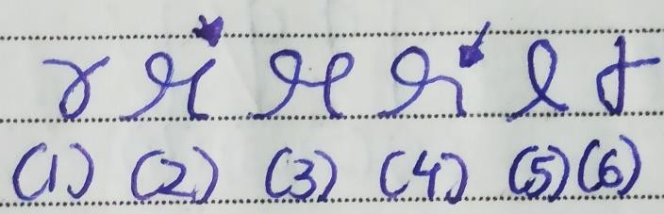

* 1. Normal r with loop, writers here feel easy to express their creativity. It is unique yet for other people, it takes time to understand. Average creativity level. Take time to solve problems.
  2. Cursive r with right side upper point, they can solve problems creatively yet criticize others to do things which they cannot do. In terms of creativity, they want the acceptance of others to feel good about what they have created.
  3. Cursive two loops, when solving a problem they are very analytical and creative which sometimes is not needed. It may take time for them to solve a problem that could have been solved quickly if they haven’t been too analytical or creative.
  4. Cursive with a right-side smooth down curve, very creative people who have the determination to execute their creative ideas. They can solve problems quickly and don’t need the acceptance of others for their creativity as they have self-acceptance. Ideal r.
  5. Reverse normal r, these writers like to break rules and have abstract creativity. In theory, their creatively idea may sound good yet practically it may not. They also take time to solve problems.
  6. Left side loop, laziness is there due to which writer doesn’t solve problems quickly.

### Angles

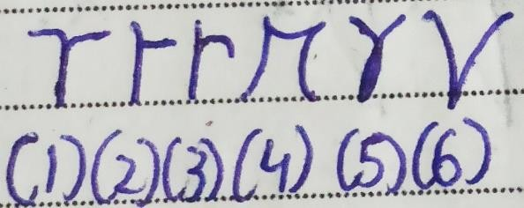

1. Normal r with two side angles, follow rules then create things due to which their creativity is easy to understand.
2. Right side angle, intelligent people in nature who are smart and have analytical fast thinking.
3. Right side curve, think more than necessary. Overanalyze things.
4. Cursive no loop, they like dull colors and have mechanical thinking instead of creative thinking.
5. Normal r with two curves, they love bright colors yet feel hard to express what they have created.
   1. formed r, instead of letting the mind wander they are forcing the creativity due to which it does not look good. They are not passionate about what they are creating.

# Letter s

### Formations

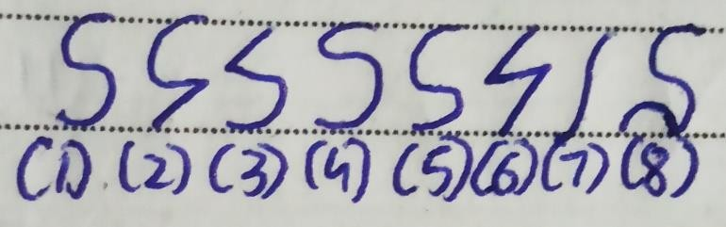

* + 1. Normal s with equal size upper and lower curves, don’t just talk about showing sympathy instead they also actually show sympathy calmly. Have very good patience levels and have the desire to improve themselves. Adaptable and can manifest smoothly. Ideal s.
    2. Upper curve, lower angle, when starting something they have good patience yet as time goes by they become analytical and impatient. They talk about calmly showing sympathy yet while executing or showing they are aggressive and analytical.
    3. Upper angle, lower curve, at the start, they are very impatient yet later become patient, and calm. They may aggressively or quickly talk about showing sympathy yet when doing they show it calmly.
    4. Upper small curve, down a large curve, they have mature mindsets who talk less and show more sympathy. Good patience as here rounded curve is present.
    5. Upper big curve, down a small curve, they talk more about showing sympathy, and doing good for others yet, in reality, don’t do everything they say. Again good patience levels.
    6. Top and down angle, these writers want to understand the process of receiving. They don't have the patience of letting things happen. In work life, they do things roughly which most often is unnecessary. They will keep tracking their amazon order again and again. Stubborn.
    7. No curve formation, a writer is very impatient and wants to receive things as fast as possible. Avoid writing like this as some things do take time.
    8. Claw in the letter s, writers here do talk about showing sympathy yet keep cheating others at the time of showing it.

### Loops

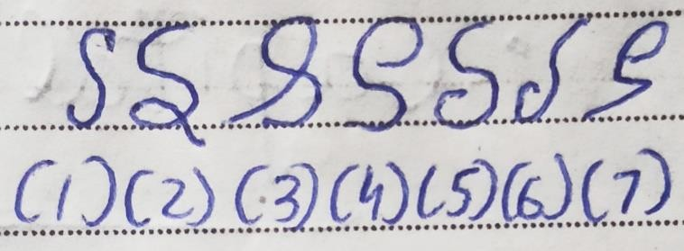

1. Narrow s, they put half effort while talking about sympathy and showing sympathy.
2. Down loop, good patience levels yet after receiving they want more instead of being satisfied. Can do well as a negotiator or in bargaining. They want to be acknowledged by others.
3. Upper loop, a writer is a responsible person who likes taking responsibility. Yet it takes more time for them to manifest things as the extra loop is present.
4. Half upper loop, these writers believe in doing something extra to get what they want. Bigger the loop more the extra effort they put which is not needed.
5. Half down loop, like to tell others about how they received or manifested their goal, dream, or anything they got.
6. Snake like s, difficult to deal with. They tend to lie and trick people into doing things they want. Very rare trait.
7. Upper curve loop and down angle, addiction and digestion problem. Very rare trait.

Letter t

### Bars In Letter t

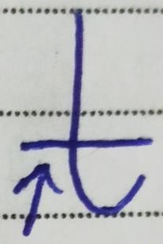

*Low t Bar*

These writers set small goals and have small dreams.

They don’t push themselves due to fears, or self- doubts.

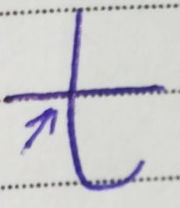

*Bar In Middle*

The bar here is balanced it’s not too high nor it’s low.

They know their limits and have dreams, and goals which are under those limits.

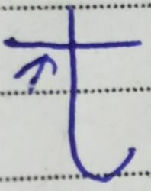

*High t Bar*

Writers here set high goals. They dream big and push themselves.

Ideal t which everyone should write as.

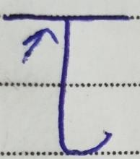

*Very High t Bar*

Visionary people have very big dreams and egos. They push themselves way more than what’s needed.

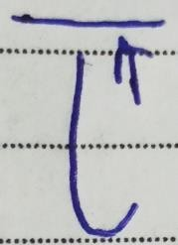

Dreamers who dream a lot yet execute less. They set unrealistic goals, and dreams.

### Direction In Letter t

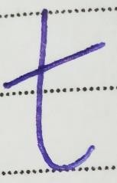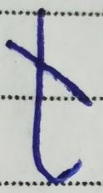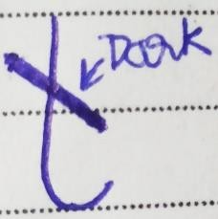

1. Upward bar means writers feel optimistic about themselves, and their goals.
2. Downward light bar show fear, and hopelessness.
3. Downward dark bar indicates an argumentative person who doesn’t just change their opinions. Stubborn, aggressive.

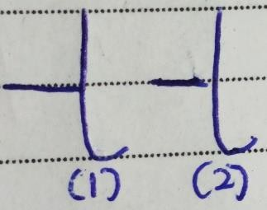

Left side bar in the Letter t shows procrastination. It is a sign of laziness. Commonly found type.

The more leftward the bar is more the procrastinator a writer is

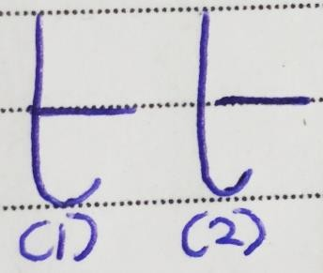

* 1. Writer is someone who likes to protect others. A future-oriented person who takes action towards goals.
  2. Here bar is overly right it means the writer is impulsive when taking action for goals. Impatient in nature.

### Bar Size

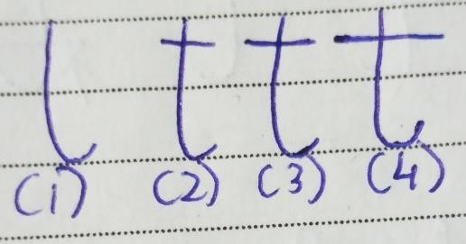

1. No Bar, careless person who lacks courage, and hope. They are unable to remember things and keep forgetting.
2. Small bar size means the writer lacks confidence, will power due to this they give half effort.
3. Medium bars show calmness, balance, and healthy confidence. They have self-control over their actions and thoughts.
4. Long-bar writers are very bold and determined. Highly ambitious people having high enthusiasm and confidence.

### Bar Curve

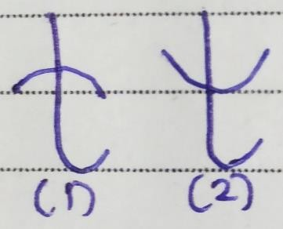

1. Writer is trying to control something in his or her life. Eg. addiction, habit. The more the concave curve more the writer tries to control things.
2. They don’t complete or do things they promised and keep giving excuses. It also shows instability.

### Other Traits

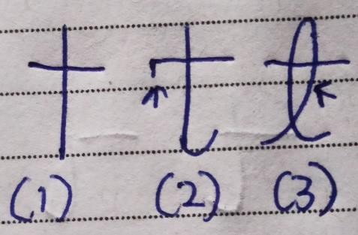

1. No hook at the bottom, these writers are very direct and may speak words that are too direct or harsh for a person to handle. Very straightforward.
2. These t writers support equality and want things to be fair. They will divide, and share things equally. Will speak up or do something if they observe injustice happening to someone.
3. Inner loop, sensitive towards criticism. So, if someone criticizes them then they will either become angry or hold grudges or show emotions or will react in some way.

Letter u

### Rounded Curves

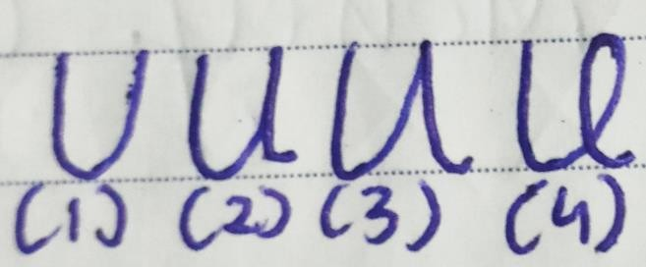

1. No right curve, writers here understand concepts more and practically apply very less. They may read a book or watch a video about driving a car and will get the knowledge yet will not practically drive the car and get experience. Theoretical learning.
2. Retracted or lower angle u, they take time to apply what they have learned. People start writing like this when what they are learning is hard to apply. For eg- Learning about driving a car is easy yet applying is hard. Take time to adapt, and have extremely high expectations and stress. They are currently in the practical learning stage.
3. High angle u, they are analytical about learning. Instead of just understanding, they like to do things practically as well. They are soft yet also sharp and will not give away their time. Have practical knowledge and now are learning more using their experience. For eg- They are practically experimenting with new ways of driving than what they had learned before.

154

1. Inner loop, writers here know yet are still confused about how to apply the knowledge practically. Instead of the main practical aspect which needs to be applied, they focus on something else. For eg- instead of getting started with driving they focus on seat adjustment, audio, AC, how many many people can sit in the car, etc. which are not essential.

### Other Types

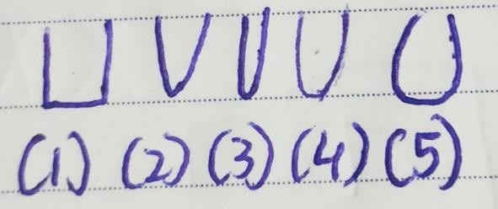

1. Angle u, analytical people who are very analytical about what they are learning or trying to understand. Rare trait.
2. Letter u was written as v, they want quick results. They act hard in situations that require softness. Instead of cutting vegetables calmly they rush and hurt themselves.
3. Narrow u, pessimistic who don’t believe in what they are learning.
4. Light u, give away their time for nothing, like charity, and are unable to give their best.
5. Horseshoe u, limit their learning, and tell others to do the same.

Letter v

### Formations

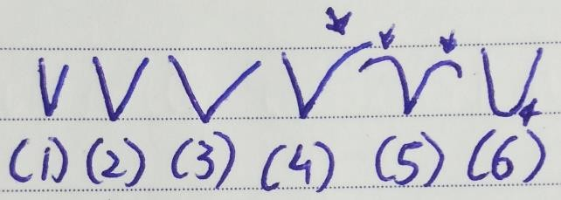

1. Narrow v, impatient writers. Take quick decisions and are very sharp. Fast grasping or learning ability. They need to do meditation, breathing, and exercise to calm their mind and eliminate stress.
2. Medium v, quickly apply theoretical knowledge to practical application.
3. Wide v, take time to learn due to a lack of interest.
4. Right side high curve, trying to escape from a situation or from what they need to learn. Rare trait.
5. Curve top v, have interest in self-improvement.
6. Letter v written as v, act slow when fast action is needed.

Letter w

### Formations

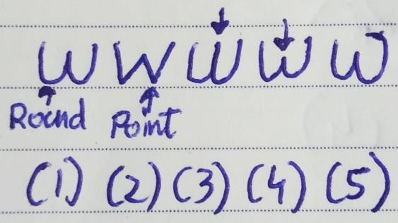

1. Rounded bottom, friendly and open personality. They are always patient whenever they are trying to form a habit from their before experience and knowledge. Eg- They have just learned about driving a car so they know it will take time to master driving so patience is needed. Able to understand others.
2. Pointed bottom, angle shows fast thinking. These writers want to form habits quickly. Eg- They have just learned to drive yet still expect to drive smoothly, and go on long rides. Not able to form full habits effectively as some things require time and practice. They keep analyzing the process of habit formation. Not able to understand others.
3. Higher middle line, when understanding women, girls, and mothers writers here overanalyze them due to which they may overthink about them which is not needed.
4. Lower middle line, instead of analyzing too much writer here accept other women, girl, and mothers’ personality. More acceptance less analysis.

160

1. Leftside u is having left curve, a writer feels closer to his/her mother and seeks closeness. Attached with their mother.

### More Formations

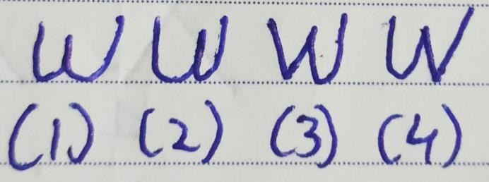

1. Rounded, first u less space second u more space, at the start of forming habit using before knowledge, experience writers here are having less patience yet as they keep going they become patient.
2. Rounded bottom, first u more space, second u less space, here it’s the opposite as the writer is having good patience at the start yet later become impatient.
3. Angle bottom first u, rounded bottom second u, at the start, they form some part of the habit quickly by being analytical, impatient yet as time goes they become slow and patient.
4. Rounded bottom first u, angle bottom second u, they are patient and slow at the start when forming a habit using their knowledge yet later become fast and analytical. So start part of the habit will be well- formed due to patience yet later one will be half- formed.

Spacing

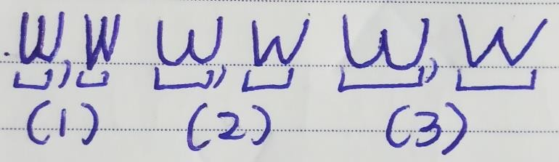

1. Narrow spacing between both u, introvert personality who may not easily be able to form habits using before knowledge which requires social interaction.
2. Medium spacing between both u, ambiverts who can form habits that require both social interaction and alone time.
3. Wide spacing between both u, extrovert type person who is communicative and have the eagerness and ambition to improve by forming habits using before knowledge. Good management skills.

162

### Size

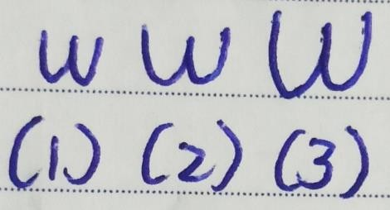

* 1. Small size, they have good concentration whenever they are trying to form habits using before knowledge.
  2. Medium size, average concentration levels. 3.Big size, low concentration levels.

### Pressure

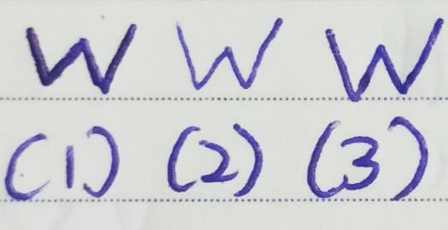

1. High pressure, more self-aware about which actions are they taking while forming the habit. Give their best and have good energy.
2. Light pressure, fewer energy levels due to which they are not able to give their best. Lazy people.
3. Medium pressure, they stand in middle they don’t give too much effort or too less effort when forming a habit.

### Loops

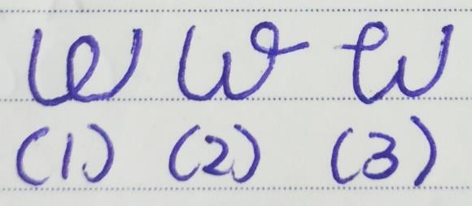

1. Loop in middle, writers here have confusion about how to form the habits using before knowledge. It could be due to half-knowledge. They also get confused about other people’s feelings, especially women.
2. Loop on the right side of the second u, like learning new things and are creative. So they form habits by adding some creativity. Rare trait.
3. Loop on the left side of the first u, don’t like talking about emotions and sometimes they do talk yet take a lot of time to open up. Rare trait.

Letter x

### Formations

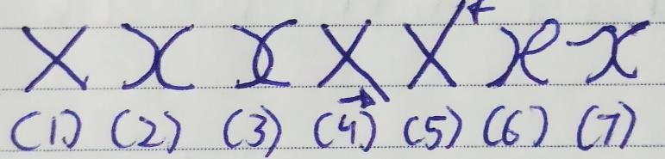

* 1. Angle, a writer here is analytical as angles are present. They try to question or debate their thoughts. Rational people, don't have a lot of emotions in their thought process. A complex way of thinking. Commonly found letter x type.
  2. Rounded Curve, these writers try to understand the thoughts instead of just questioning them. As compared to pointed x, writers here have more overall clarity in their thoughts which helps them explain thoughts simply. Emotions are connected to their thought process. Passionate people, other people get influenced.
  3. Rounded curve with inner loop, they also try to understand their thoughts yet instead of focusing on one side of the thought they focus on another as well due to which they fall in the middle and get confused. Eg- I must eat a burger because I like it no I must not eat it as it is not good for my health.
  4. Pointed x right down stroke, hot temper. Get temper due to a lot of questioning or debate with the thoughts. Instead of letting it go, they keep questioning.
  5. Pointed x right upper stroke, ambitious people. They question their thoughts to see if what they are thinking is an ambitious goal or not.
  6. Curve x with a loop on the right side, they can think and express good jokes. Very rare trait.
  7. Extra leftside curve on curve x, artists who have good rhythm in thoughts. Rare trait.

### Width

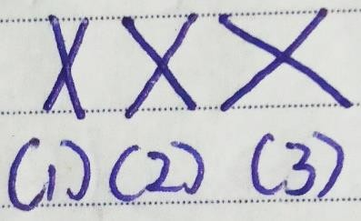

1. Narrow x, they want to quickly question their thoughts and get answers.
2. Medium x, they have the patience to question their thoughts and wait for an answer. Balanced.
3. Broad x, have a lot of patience to wait for the answer. Sometimes it could be more than what’s needed.

168

### Different Direction

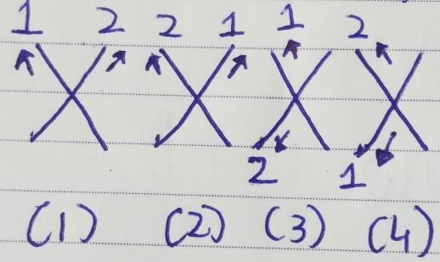

Look at the number and arrow on the image to observe the direction. Number 1 shows the first line drawn while number 2 shows the second line drawn. While the arrow shows an upward or downward direction. You would need to tell the writer to write x in front of you to analyze this type.

* 1. Writers who are more focused in past. They keep questioning themselves about past events.
  2. They are also focused on the past yet they are haunted by the past as they haven’t released their attachment to those negative events.
  3. Focused on the future yet still looking at past events.
  4. Independent thinkers, like being in control so they keep questioning if they are independent or not. Rebels who oppose authority.

### More directions

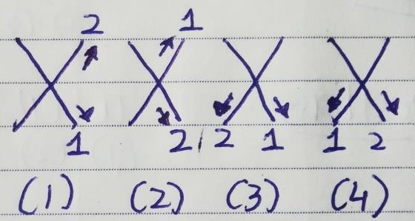

1. They also have independent thinking yet they don’t oppose authority.
2. Strong personality who has rational thinking.
3. Correct way of writing x, like being organized and having things in order. They keep questioning themselves if things are in order or not.
4. Creative people in nature who think outside of the box. They keep thinking about how they can do things differently.

# Letter y

### Loops Size In y

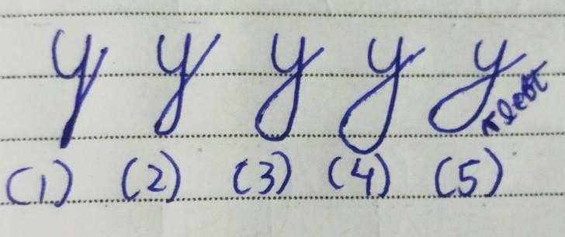

* 1. They are trying to control their sexual, and emotional needs. The reason they don’t enjoy sex.
  2. These writers are anti-social and don’t have an active social life. They spend very less money.
  3. shows a balanced social life, sex life, and finances. They don’t have a problem with intimacy and can control their desires when it’s needed.
  4. the writer wants a lot of money, cars, jewelry, etc. They also like variety in physical activities and like to dominate physically.
  5. Writers here are dwelling on past patterns, and thoughts related to relationships, finances, and social life. They depend on others for their emotional needs.

### Incomplete Loops In y

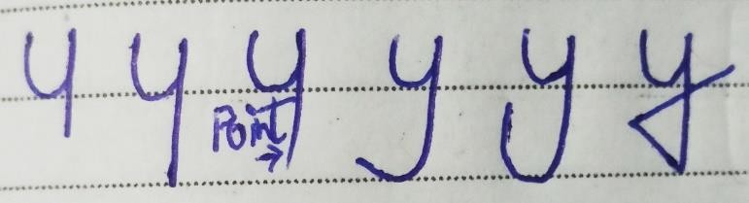

1. Very low sex drive, social life. Reserved type personality. Shy person.
2. Loner who feels more comfortable being alone. Do not just open up fully to new people. Independent thinker. Value space in a relationship. May lack sexual fulfillment as they don’t just connect emotionally with another person.
3. These writers have sexual restlessness. Rarely found trait.
4. They repeat the same life mistakes/lessons over and over be it about relationship patterns or social finances. There is some physical frustration due to which they are unable to give their best during sex.
5. These writers are physically frustrated which could be about their lower body, exercise, or sexual activity. They are confused and feel unsatisfied.
6. Feel sexual anxiety and have some anger towards the opposite sex. Not a good trait to have.

46

### Negative Letter y

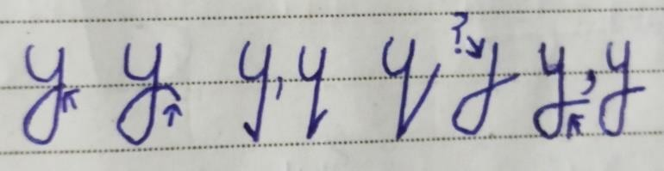

* 1. They do start many projects; investments yet are unable to finish all of them as the loop isn’t completed fully. So, they don’t give up or keep going instead stay in middle.
  2. These writers give up at the last moment. They have fear of success the reason they are unable to achieve goals. Avoid writing like this.
  3. Small angles towards the left (past) or right (future) show impatience and anger.
  4. Big Angle, they are moving away from sex and are not straightforward about this topic.
  5. Writers here don’t focus on sexual energy, social finances, or relationships.
  6. Loop doesn’t reach the upper line; these writers do not trust others easily. This happens due to past incidents (Betrayal by someone). The smaller the loop more the time they take to trust. Not good for a relationship.

# Letter z

### Formations

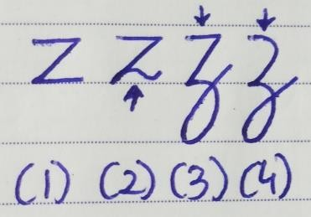

1. All Angles, desire to know how manifestation happens. Angles also show impatience. Can make quick judgments. They believe their own opinions are always right and everyone else should agree with them.
2. Upper angle and down curve, adaptable people as both angle, and curve are present. According to the situation, they change their behavior. They want to understand the manifestation yet in a calm manner instead of rushing up. Mature people in nature.
3. Upper angle and down loop, they physically want to do something to understand, increase manifestation. They want to see live results quickly.
4. Upper curve and down loop. They too want to physically do something yet cannot wait for live results. C

CAPITAL A

### Formations

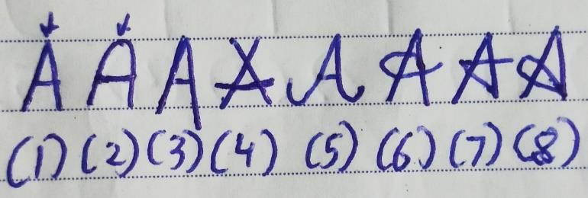

1. Pointed A, writers here are analytical whenever they are giving something or receiving something from others. They keep thinking about why this gift was given or why should I give this gift to them. Less emotional about giving, and receiving. Rational people.
2. Rounded A, here writer tries to understand others whenever they receive something or are giving something. So at the start, they don’t think about why this was given to me. Soft-hearted who don’t like to hurt others so they don’t get angry even if they have not received what they wanted. When giving something they like to connect with it emotionally.
3. Right downstroke, they show some temper if they haven’t received what they wanted.
4. Cross A, careless people who at the start say things that hurt others. So even if they have received something from another person they criticize the other person. The same is while giving. Have relationship issues, a rare trait.
5. Both sides round down the curve, writers who can adjust to traditions. They think a lot before giving something as an extra curve is present and do the same after receiving something from others. Rare trait.
6. Loop in middle, they show appreciation via emotions and creativity after receiving something.
7. Line going on left and then going to the right, persistence can be said here as a writer goes back to the past and move towards the future. After receiving something they compare what they had given before to that person and then think about what they have received now.
8. Loop from down, a writer who like culture and will like to receive and give things related to their own or another person’s culture.

### Width

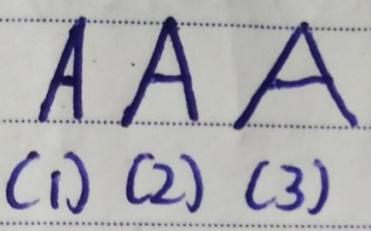

1. Narrow A, they are good at negotiations as they don’t like giving more.

212

1. Medium A, here writer is broad-minded and will give another person what that person likes even if the writer doesn’t like it. Able to find good in situations.
2. Wide A, givers who like giving and are kind- hearted. Like to give to charity, and help others. Do not expect anything in return.

### Direction

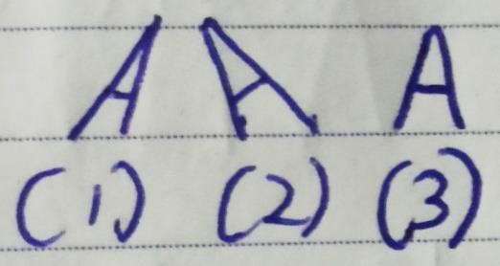

1. Rightward direction, these writers want to give something to the other person before expecting something in return.
2. Leftward direction, writers here first want to receive something from another person before giving.
3. Straight direction, the writer is willing to give even if other people haven’t given them before and is willing to receive if they haven’t given something to them before. Common A type in many handwritings.

### Other Formations

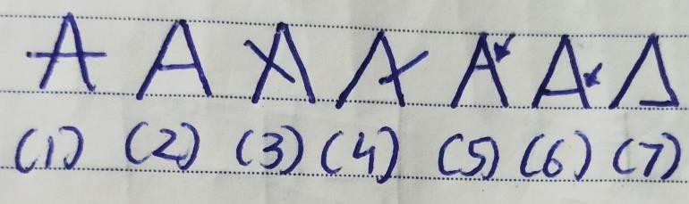

The longer the middle line more the writer’s confidence depends on other people’s opinions.

1. Middle line crossing over with sidelines, they like to take chances even if they are not confident about it.
2. Balanced middle line, have good self-confidence in things they are giving. If the middle line is longer then the writer’s confidence depends on what other people say about things they have given.
3. Crossover upward line on the left side, writers are confused about giving. They keep thinking should I give this? Or Should I give that? Conflict keeps happening in their mind about this.
4. Crossover upward line on the right side, here confusion and conflict are about the results, and things they have received.
5. Upper middle line, they like to give something which helps them connect with others via communication instead of emotion. Eg- They will compliment others with dry words instead of emotional ones like “I like hanging out with you”

214

instead of “I feel happy and loved when I hang out with you”. Have more confidence in what they are giving.

1. Down the middle line, have less confidence about things they are giving. So they will submit to what others want them to give or what everyone is giving.
2. Very down middle line, they are reserved. Can be a good architect. Very rare trait.

CAPITAL B

### Formations

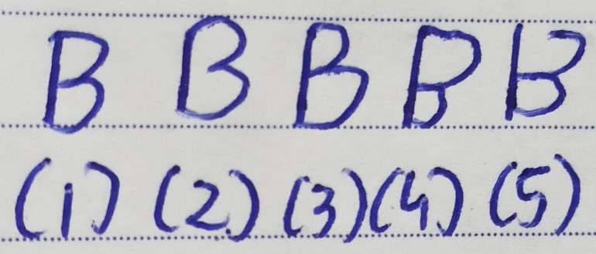

1. Here all 3 points are in contact with the stem. Whenever they make a decision that requires thoughts, emotions, and instinct connection they first think about it then they focus on what they are feeling about it, and at last, they focus on their gut feeling to see if it's the right decision or not. They work effectively and have good blood pressure.
2. First and third points are in contact, writers here ignore emotions. They first think and then directly focus on instinct to make the decision.
3. Second semi-circle larger, a writer here does connect thoughts, emotions, and instincts when making decisions yet more importance is given to emotions and instincts connection.
4. First semi-circle is larger, here it’s the opposite. The writer gives more importance to logic and emotional connection and less to instinct connection.
5. No point of contact at the first point, they are not thinking logically and instead are just focused on emotion and instinct connection.

### Other Formations

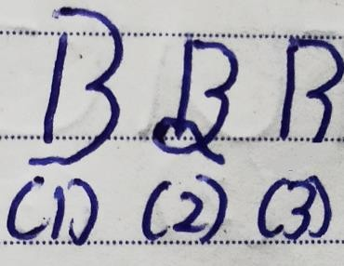

1. No point of contact, casual person who takes decisions casually due to which they take bad decisions, wastes time doing things which give no result.
2. Small loop at the bottom and no point of contact in middle, they do think yet value instinct and creativity more and ignore emotions.
3. No point of contact, at last, their blood pressure needs improvement. They work more than what's needed and on things that are not giving them results. As they don't focus on using instinct when deciding to start something instead just focus on thoughts and emotions. Less self-awareness.

CAPITAL C

### Formations

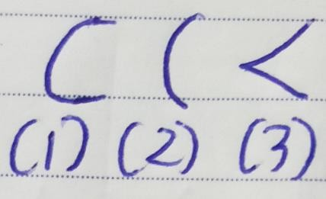

1. Ideal C, at the start they feel comfortable socially, outside their comfort zone, and have good social confidence. They don't compare themselves with others. Have patience. Compare this C with their small c to find what they feel after some time.
2. Half C, at the start they feel low social confidence. Compare themselves with others. Feel uncomfortable about how they look and dress. Not able to speak on stage or in front of strangers. Some writers feel like this at the start yet once someone compliments them or they meet someone they know, they feel comfortable. So again do check small c as well.

3.Angle C, very analytical at the start, keeps thinking is this environment right for me, are these people good? Etc. Very rarely found

CAPITAL D

### Formations

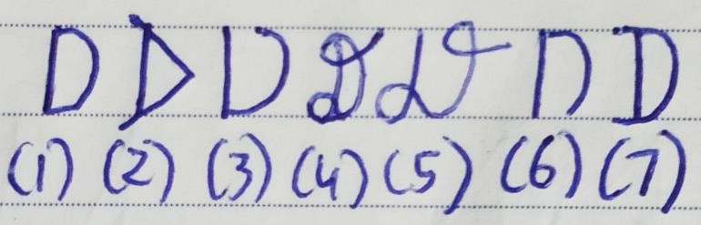

* 1. Normal D, if the writer first makes the semi-circle from upper to lower point then the writer focus on their thoughts and later focuses on instinct to make the decision. And if the writer first makes a semi- circle from the lower to upper point then they first focus on their gut feeling and then think about doing something. If in their gut it doesn’t feel right then they don’t think much about it and don’t make the decision.
  2. Angle, writer is quick in decision-making as they quickly focus on what they think about and then quickly focus on instinct to see if it’s right and make a decision. They use past thoughts, and instincts as well when making the decision. Rare trait.
  3. Upper point gap, the writer focuses more on instinct and ignores thinking. Sometimes it may work yet most of the time logical thinking is important as well along with gut feeling or instinct.
  4. Loop at the bottom and top, they are reserved in nature. They want to feel some emotions as well along with thinking. And along with instinct want to think creatively as well. For eg – will this help me be more creative?
  5. Loop at the bottom and incomplete loop at the top, they don’t focus on thoughts and instead want to understand. They also don’t why should they understand it (No point of contact). So whenever they are making a decision they want to first understand what they are doing and then focus on their instinct and creativity.
  6. Gap at the bottom, here writers ignore instinct and just focus on their thoughts.
  7. Extra upper and lower points, along with present thoughts and instinct writer use their past thoughts and instinct as well when they are making a decision that requires thoughts and instinct connection.

# CAPITAL E

### Formations

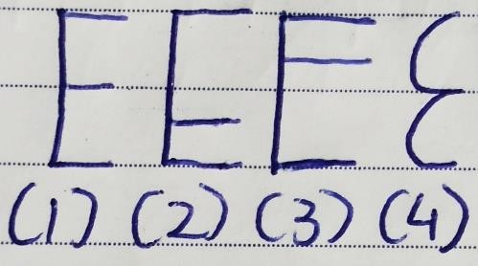

* + 1. Equal bar size, a writer who writes like this express their thoughts, emotions, and instinct equally. For eg- If they have a gut feeling that something bad is going to happen then they will say it. Similarly, they express their emotions and thoughts. Sometimes that expression could be aggressive as an angle is present.
    2. Middle bar lower, the writer does express their thoughts and instinct yet instead of emotions they like to express their creativity, and sexuality. If the middle bar is lower then they express their trust. In case the middle bar is between emotions and creativity then it shows an expression of confidence.
    3. Middle bar higher, instead of emotions they express their communication ability (speaking, writing). If the middle bar is a little higher than that then it shows expressing their understanding and the very higher middle bar shows knowledge expression.
    4. Curve E, these writers also express their emotions, thoughts, and instinct openly yet they are not that

aggressive. They express themselves in a way that others can relate to at the start.

### Size

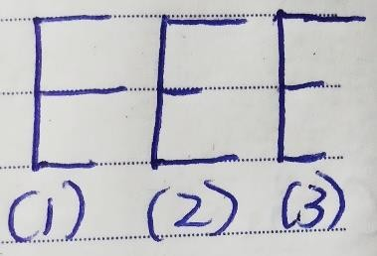

1. Middle bar longer and the lower bar is very short, writer here expresses their thoughts as they are yet they express emotions more than what’s needed. Along with that instinct is less expressed as the bar is short.
2. Middle bar is very short, upper and lower bars same size, these writers don’t express their emotions completely yet they express their thoughts, and instincts in a balanced manner.
3. Upper bar is longer and both other bars are very short, they express their thoughts more and give less importance to expressing their emotions and instinct.

CAPITAL F

### Formations

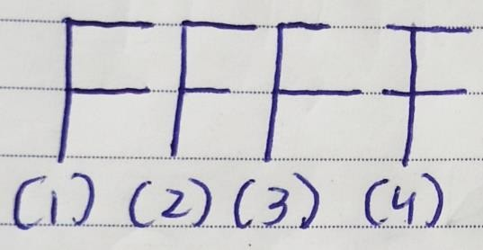

* 1. Same size first, and second bar, the writer express both emotions, and thoughts equally.
  2. First bar normal, second bar short, a writer here gives more importance to thoughts than emotions when expressing. So they give more importance to logic than emotions. Commonly found letter F.
  3. First bar short, second bar normal, since the middle bar is longer these writers give more importance to how they are feeling or their emotions. Express more emotions.
  4. Crossover bars, these writers are argumentative. Instead of expressing themselves, they argue with their thoughts and emotions. So it takes time for them to express or take decisions that require both emotional and logical thinking.

### Other Formations

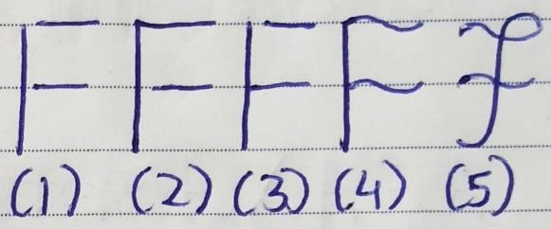

1. Gaps between stem and both bars, not able to understand what they should do. They are not able to understand their emotions as well as thoughts.
2. Gap between the stem and the second bar, have a problem in understanding what they feel. They believe they must express their thoughts yet emotionally they still are unsure.
3. Gap between the stem and the first bar, here it’s the opposite as the writer cannot understand their logical thinking or thoughts. Feel emotionally right yet logically unable to understand.
4. Wavy bars, casual approach while expressing. They don’t seriously focus on what they are thinking or feeling.
5. Loop at the top, cross wavy bars, and bottom left side curve, they are more creative yet focus on past logical, emotional decisions or expressions they have done to express now. Have a casual approach. There is some focus on past instincts as well.

CAPITAL G

### Formations

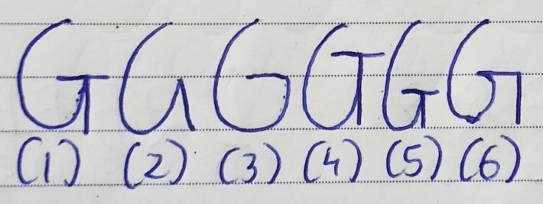

1.C with T medium size, they always have a goal in mind or know what they want to buy or do. Yet they are analytical since the angle is also present here. So even if they have a goal they still analyze if buying or doing something socially is good or not. They set medium-level goals not too high nor too low.

2.Angle formation, these writers are also analytical before buying something or doing something socially as the angle is present here as well. Yet they buy randomly or do things randomly instead of having a goal.

3.G like Google, the left side shows the past. Writers who write like this focus on past decisions, and actions to buy or do things socially in the present. Google show result on content websites that have been created before, so you if search “Graphology” then it will search websites that in past have already created videos or blogs, or posts on Graphology and will show you that on screen in present. No specific goal.

4. Higher T, these people set high goals when they want to buy or do something socially.

5.Lower T, opposite of before G, writers here set small goals.

6.G formation with left side T, they do set goals yet focus more on past decisions they have taken to do or buy things socially in present.

# CAPITAL H

### Bonding With Others

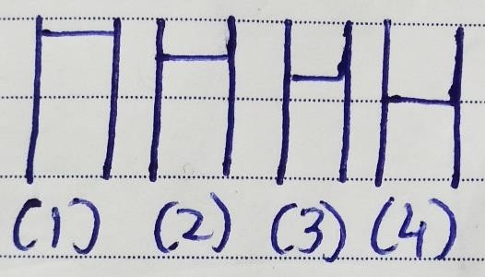

Here we are ignoring width and just focusing on the middle bar position.

1. Very high middle line, they like to bond with others, and ideas via spirituality, thoughts, and knowledge.
2. High middle line, trust, and awareness are important for them. They only bond when they trust or are aware of the other person or an idea.
3. Little high middle line, bond with understanding. They want to understand other people via communication and expect other people to understand them as well.
4. Middle bar, a common type found in many handwriting. Writers here want to bond with emotions. They want to feel something about the other person or idea to bond.

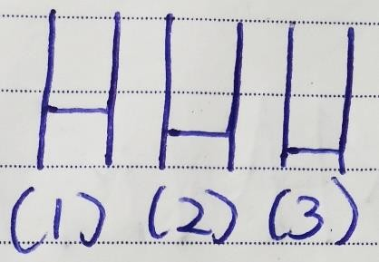

* 1. Line a little bit lower than the middle position, bond with personality, and wisdom. Many people bond with others because they like one’s personality and these people write H like this.
  2. Line lower, these writers want to bond with another person via sexuality. You may find many just married couples writing H like this. They also like bonding with others via creativity.
  3. Line very lower, like bonding with comfort and stability. They give comfort and stability a priority when they want to bond with others at the start.

### Width

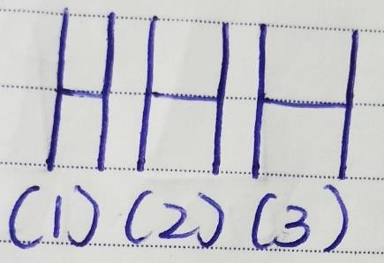

Here we are ignoring the middle bar position and just focusing on the width.

1. Narrow H, they are shy when bonding with someone, or something. Take some time to open up and bond.
2. Medium H, these writers are bold and like to do difficult things. So when bonding with someone, something they like to take the risk.
3. Broad H, broad-minded people who respect other people's opinions even if it's the opposite when bonding. More comfortable with new people.

### Other Formations

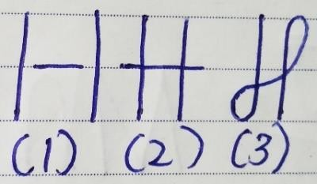

1. Gaps between line and stem, as the line here is in the middle position writer here is unable to connect emotionally with another person. Different positions of the bar would have shown difficulty in connecting with another person via that aspect. Eg- Trust
2. Crossover on both sides, here too position of the bar is in middle. Writers get in conflict when they emotionally try bonding with other people, and ideas.
3. Loop on stems, they connect with others via their past instinct and creativity along with current emotions and other person’s future creative thoughts.

# CAPITAL I

### Relationship With Parents

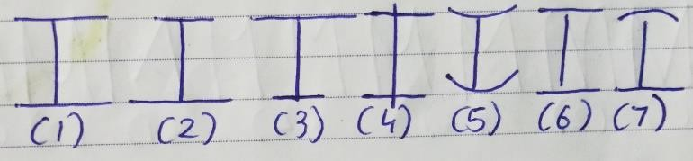

1. Equal size of both lines, the writer is having equal influence and support of both of their parents or with both people who they see as a mother, and father. They have good relationships with their parents as well. Here it doesn’t matter who is the base of the family as the writer is having good relations with both.
2. Upper line is short, a writer here is not getting support from a family member who is in feminine energy or someone who is not dominant in the family.
3. Down line is short, here it’s the opposite writer is not getting support, and is having less influence from the dominant member of the family. It could be a father or mother. Do ask the writer who is the dominant member.
4. Crossover in both, a writer here is having conflict with both of their parents. It could be due to some past or current events. Yet if writers want to improve his/her relationship with their parents then they must write like fig.1.
5. Curve lines, as we have seen in the letter t, writers having concave bars like this indicates giving excuses. Here since both bars or lines are about parents. The writer’s parents keep giving excuses for not doing their best. Rare trait.
6. Gaps between both bars, have a problem in connecting with their parents. The gap on one side (upper or lower line) indicates a problem in connecting to that specific parent or mother/father figure.
7. Upper concave bar, firstly gap shows unable to connect with the mother or with someone who is not dominant. And down concave like here show control, the writer’s mother is trying to control them in some way. They want their mother to improve.

### Other Formations

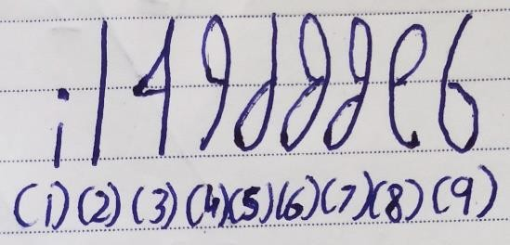

1. Capital I written as small i, writer feel insecure about themselves. Have problem in initiating.
2. Straight line, the writer is an independent person who didn’t feel the need for the support of parents.

3.I have written as 4, unable to understand the other person’s viewpoint or what they are trying to say.

1. Top loop on the left side, as we know the left side shows past. Write here is having some past creative influence of their mother figure. The influence could be good or bad.
2. Bottom loop on the left side, a writer here is having the past creative influence of their father figure or someone dominant at home (mother or father). Again it could be good or bad.
3. Joined loops on the left side, joined past creative influence is there so both mother and father have equally influenced the writer.
4. Unjoined loops, here it’s the opposite as there is no joined influence. Unequal influence of both parents. One could be good one could be bad.
5. Top loop on the right side denotes the future and these writers have the future creative influence of their mother figure. Rare trait.
6. Bottom loop on the right side, opposite of before, writers have the future creative influence of their father figure. Rare trait.

# CAPITAL J

### Formations

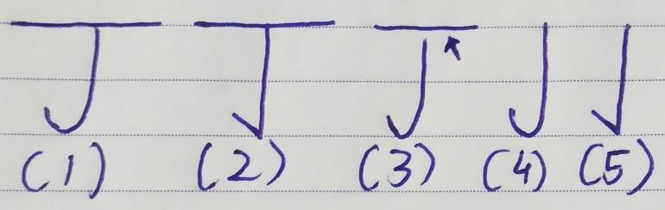

1. Upper line with a round bottom, a writer here first think about the past and future and then instinctively react slowly in present. Eg – A professional singer may first think about how they had sung a song in past and how they could improve it in the future. And after thinking about both they instinctively react or sing in the present yet they take some time to prepare.
2. Upper line with pointed bottom, these writers do the same yet they instinctively react more quickly. Eg- Here the singer quickly reacts by starting to sing the song without much preparation.
3. Gap, unable to connect instinct with their thoughts. They may instinctively react in a different way than what their thoughts are telling them to.
4. No bar and rounded bottom, here writer just thinks about what they can do now and instinctively react. They also take some time to react as the round bottom is present. Eg- A professional singer directly starts singing instead of focusing on how they sang in past and could sing in the future.
5. No bar and pointed bottom, they instinctively react quickly based on what they are thinking. Don’t think about the past or future.

CAPITAL K

### Different Positions

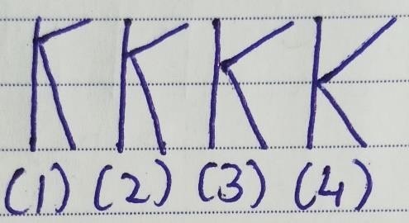

1. Very High, writer here wants to make things different via spirituality. So instead of hosting a DJ party, they will host a yoga or spiritual session.
2. High, full trust and awareness are important for them. Spreading some awareness or making other person, people aware of society's problems, life, and the world, etc. is how they make things different.
3. Little high, they want to make things different via understanding, and communication. They will communicate with the person and understand their problems, life views, etc. Also, writers here will give a speech, sing a song, send a text or video, or image, write a letter, teach differently, etc.
4. In the middle, these writers want other person or people to feel emotions. They could host a romantic dinner, pay a surprise visit to their friends, play the wedding video, and try to do something which can generate nostalgia, emotions, etc.

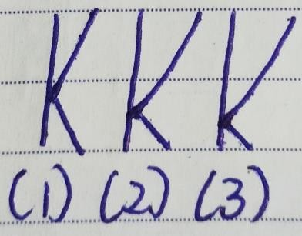

* 1. Little lower, a writer here will make things different by sharing their wisdom. They will tell people how they applied what they learned practically, will share their experience, etc.
  2. Lower, they want to make things different via sex, food, and creativity. They may want to experiment with different sex positions or with different types of food or will show creativity differently.
  3. Very low, since it’s way lower these writers want to make other people feel comfortable which they want to do by gaining some basic trust.

### Other Formations

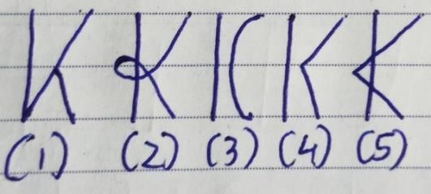

1. Angle present in middle, there is an analytical way of expressing or making things different via emotions due to which the feeling of emotions is less.
2. Loop in the middle, It is a complicated way of making things different. Other people do connect a little yet get confused about what the writer is trying to do.
3. Gap and round curve, they are a little slow in doing things yet because of the gap other people are unable to relate or connect with what they are doing.
4. Gap and pointed angle, fast in doing things yet just like above here too people have a problem connecting with the writer’s efforts.
5. Crossover, just like small k here as well writer acts desperate and wants to convince others about how they have made things different for them.

# CAPITAL L

### Formations

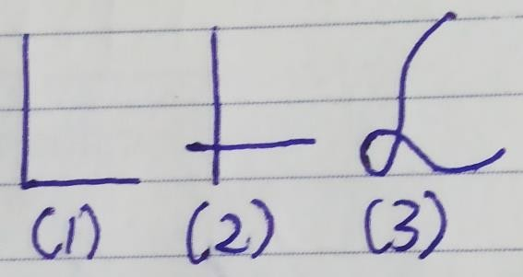

1. Common L, straightforward people who directly express their instinct. So if they get a gut feeling that something is wrong or even right then they express it directly. Sometimes it could be harsh for some people.
2. Crossover, they express instinct which leads to an argument, or conflict. Need more maturity about which instinct to express and how to express it.
3. Stylish L, while expressing their instinct or gut feelings they are calm, and gentle instead of too direct or harsh. Even if the feeling is negative they are going to express it gently. Loop here shows creativity the reason they add some creativity while expressing. Found in Greeting Cards, Love letters, and Creative designs.

# CAPITAL M

### Common Types

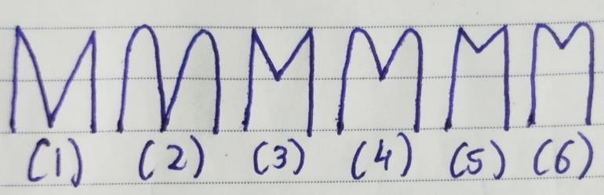

* 1. Pointed M, they like to do things quickly as pointed angles are present. So when forming a habit they think a little and go for it. The angle is present at the bottom which means the writer focuses on instinct to see if the habit they are forming is right.
  2. Rounded M, because of the rounded curve these writers think a lot before starting habit formation or selecting a habit. Here writer uses instinct to see if the habit is right.
  3. Pointed M having an angle in middle, writers here are fast about selecting, and forming the habit yet they focus on emotions to see if the habit is worth forming. They only form a habit when they emotionally feel something about it.
  4. Rounded M having an angle in middle, they take time to select a habit yet like above use emotions to confirm the habit they want to form.
  5. Pointed M and angle higher, communication plays an important role for them. When forming, and selecting a habit they think if the habit can improve their communication skills. Eg – Habit of speaking,

listening, etc. Again they are quick with habit formation due to the pointed side angles.

* 1. Rounded M and angle higher, just like above here too writer gives more importance to communication yet they take time to start and select a habit.

### Other Types

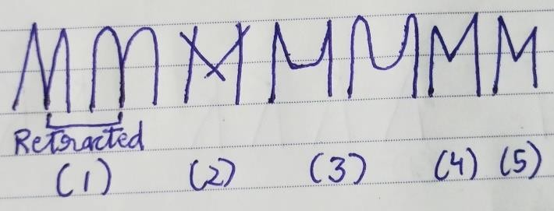

1. Retracted pointed, rounded M, retracted means the writer wants to be fully sure about the habit instead of feeling just right they want full confirmation. Have a problem making changes while habit formation as they again want to be fully sure about the new changes.
2. Crossover M, confusion is there as they are unable to make a decision. Keep questioning why should I start this habit. Less clarity is there due to which they get confused and don’t start the habit formation process.
3. Rounded Middle, a writer here wants to understand the habit formation process instead of just taking actions. Take more time to start the habits yet they are more smooth.
4. Right side upward angle, public opinion is important for them so they choose the habit that other people want them to form. Rare trait.
5. Left side upward angle, self-opinion is what they only look at it whenever they want to start habit formation. Instead of both self, and public opinion they only focus on what they want. Rare trait.

CAPITAL N

### Formations

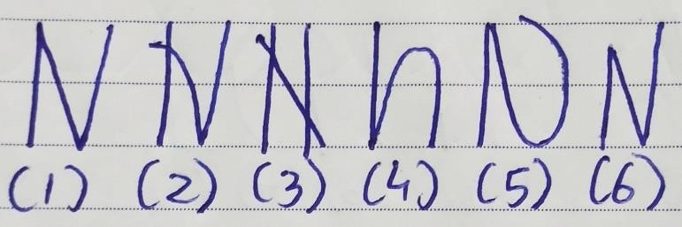

1. Pointed N, they quickly take decisions. For Eg- They quickly decide on vacation spots, grocery store lists, and other things which are short-term activities or things we do occasionally. They focus on instinct to see if the decision is right or wrong.
2. One Crossover N, is unable to make decisions. They keep arguing with themselves, and others about it. For eg- Should we go to this place? And after deciding they again keep thinking no we should not or should we?
3. Crossover N, conflict with awareness is there so a writer is unable to be sure about why certain short- term activities need to be started. Eg – Why should we go to this place? They don’t decide.
4. Stem and rounded N or N was written as n, now here at the start writer do react quickly as they get the instinct to do so yet they take time to start the short- term activity. Eg - They suddenly get an instinct about watching a movie so they quickly go to the theatre to buy the ticket yet once there they take a lot

266

of time to buy the ticket as the rounded curve is present.

1. Angle at the top, round at the bottom, and backward curve, the writer is protective about themselves so they may not do an activity that involves some risk. Very rare trait.
2. Second angle higher, opposite of the above N these writers want to do short-term activities that involve risk and uncertainty.

CAPITAL O

### Different Types

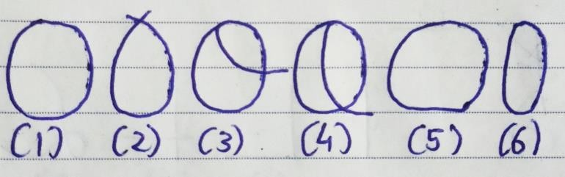

1. Normal O, after completing a particular task these writers feel relaxed in a way instead of just jumping into another task. While completing too they don't think about the next task. For eg - Finally, I completed this book. I feel calm and relaxed.
2. Crossover at the top, because of crossover these writers keep questioning themselves after completing a task or thought. For Eg - Have I

completed this book? They don't feel satisfied after completion.

1. Short right-side inner loop, writers here want to start the second task just after completing the first task. Instead of relaxing, they want to jump into the next task. They are not feeling emotionally satisfied. Eg – Finally I have completed this book yet I don’t feel emotionally happy yet anyways let’s start the second book.
2. Large right-side inner loop, writers here are just trying to complete the tasks one after another instead of enjoying the process. No emotions are involved here instead they ignore what they feel and keep going from one task to another like a robot. Eg - Finally I have completed this book now let’s start the second book as I need to complete the second book to start the third one.
3. Broad O, after completion of a situation or thought they take more time to just relax, be calm, and do other things before starting with the next task.
4. Narrow O, a writer here doesn’t jump into new tasks yet they are not able to fully relax, and be calm after the completion of a situation, or task.

CAPITAL P

### Formations

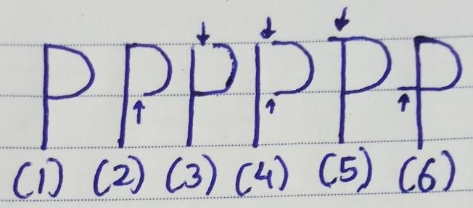

Complete P, they make decisions using thoughts, and emotions. The reason they feel logically as well as emotionally satisfied. Eg- They buy a car that they think is needed and that they feel is a good choice or they married someone who they thought would be a great choice and also for whom they felt real love.

1. Gap at the bottom, a writer is feeling logically satisfied yet emotionally unsatisfied. For eg – They married someone who they thought would be a good choice yet now have a problem feeling love and happiness with their significant other.
2. Gap at the top, here it’s the opposite as the writer is feeling emotionally satisfied yet logically unsatisfied as they took a decision based on what they were feeling. Eg – They bought something just because they felt good about it. Married someone because they felt good about the person.
3. Gap at the bottom, top, they don’t focus on emotions as well as logic when doing something due to which they take wrong decisions or in some cases would follow what others are doing. For eg – Just because everyone is getting married I must get married to someone even when I don’t feel like doing it. They also don’t think if they want to do it.
4. Extra extend at the top, these writers do feel sure emotionally yet logically they are unsure if they should do, or buy something. Eg – Emotionally I feel this is the right person yet I believe I need more time for commitment.
5. Extra extension at the bottom, a writer feels logically right yet emotionally they feel unsure. Eg - My mind says yes yet my heart is currently unsure.

CAPITAL Q

Different Ways Of Asking Questions

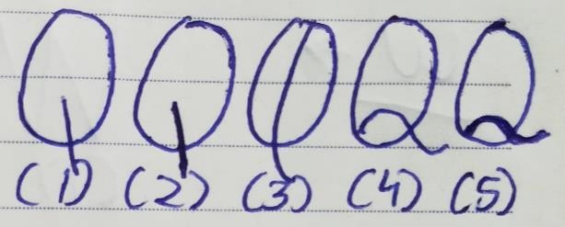

1. Line at the bottom, writers here like to ask random questions instead of before-prepared ones. For Eg- After completing the speech the journalist will ask random questions to the speaker.
2. Heavy pressure line, they too ask random questions yet they ask with more energy. Sometimes they could be aggressive as well while asking since heavy pressure show high energy as well as aggression.
3. Large inner loop, these writers are well prepared so they have a list of questions they want to ask. For Eg- After completing a speech a journalist will ask certain questions to the speaker that they have prepared before. Good at debates.
4. Small bottom loop, they ask random questions creatively. A higher loop shows asking random questions with confidence. These questions could be more future-related.
5. Heavy pressure with a small bottom loop, there is high energy, aggression along with creativity in their random questions.

# CAPITAL R

### Formations

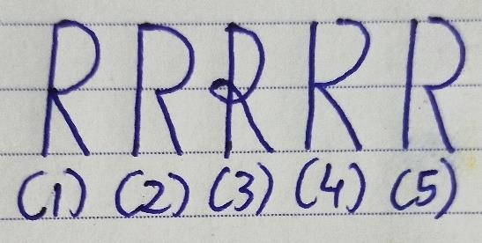

* 1. Normal R, they don't just make the same mistake again. Their instinct remembers what they thought logically and how they felt emotionally when learning or doing or buying something. Eg – They buy chocolate and eat it, and now logically they thought it’s expensive and emotionally they feel sad for wasting money on it. Next time in the future when they want to buy chocolate their instinct will trigger telling them to not buy that chocolate as before in past they didn’t feel logical as well as emotionally satisfied with it.
  2. Gap in the middle, they instinctively remember things with logic or about what they thought at that time. Their instinct doesn’t remember how they felt so they may make the same mistake because of emotions. Eg – When eating chocolate they only focused on thinking about the chocolate price. So in the future, their instinct will only trigger the price of the chocolate not how they felt after eating the chocolate. Due to this, they may again buy the chocolate as currently, they could be feeling happy.
  3. Loop crossover, they take a lot of time to learn with instinct. And have emotional confusion. So if they buy chocolate and that's not tasty then they feel it's their mistake or it happens so they will try again etc. Logically they do believe it's not good yet emotionally they think let's try again.

1. Gap at the top, here while learning writers just focus on how they felt not on what they were thinking. Due to this their instinct only remembers emotions. Eg – They only instinctively remember that the chocolate they bought made them feel sad. So in the future, their instinct only triggers what they felt about the chocolate due which they could buy again because logically their mind tells them to do it.
2. Both gaps, casual people who while learning, doing, and buying don’t focus on what they felt and thought. Their instinct doesn’t remember anything. Eg – They bought the chocolate and ate it without thinking if it is expensive, or tasty. Along with that, they didn’t focus on emotions to see how they felt after buying and eating it. In the future, they again buy the same chocolate as instinct triggers nothing.

# CAPITAL S

### Formations

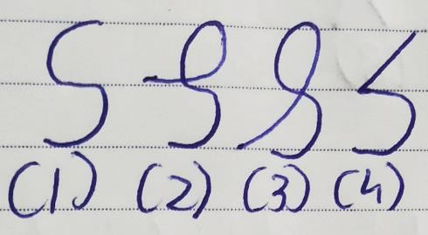

* 1. Simple S, these writers know that certain journeys and projects are going to take time yet still they start them quickly. Have an attitude of patience and like to enjoy the process. For Eg – I am going to look at the side scenes, nature, shops, and people.
  2. Loop in middle, they keep thinking about what they are going to do after reaching that destination. Eg – After reaching there I will take many photos.
  3. Loop from top to bottom, if the loop is in a downward direction then the writer is slow in initiating the journey or slow to start things that they know are going to take time. Eg – Before booking let me research a lot about what to pack, hotels, and documents.
  4. Angle at the start, round at the end, writers here are analytical at the start yet later become patient and try to enjoy the journey. Eg – At the start, they think, have I got the tickets for the trip? and after checking they become patient.

### Other Formations

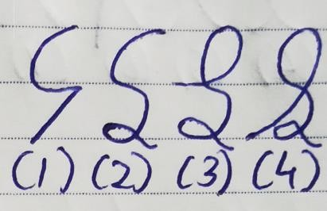

1. Round at the start, the angle at the end, opposite of the before S, they are patient at the start yet suddenly become analytical. Eg – Journey is going so well oh wait did I have the ticket with me?
2. Lower Loop, they have more patience and feel ok even if the journey they expected to complete is going to take more time.
3. Loop in the middle and lower loop, they do emotionally focus on what they are going to do after reaching the destination instead of the journey yet they also have the patience to wait if suddenly the journey is taking more time to end.
4. Loop from top to bottom and lower loop, a writer here is slow to start the journey yet they also have the patience to wait if something is taking more time than what was expected.

# CAPITAL T

### Formations

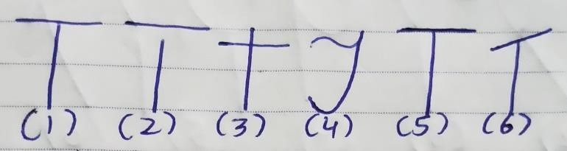

* 1. Normal T, start realistic projects. Give full effort while doing so as they believe they can do it. They understand their capacity and that's the reason they can start realistic projects. For eg – I have vast experience in my field so I can now expect a high salary from my new job.
  2. Gap at the top, these writers are dreamers who initiate unrealistic projects and don't take action for completing those projects instead keep dreaming about them. For eg – I am a fresher with no experience yet still I can expect a high salary as I have a degree.
  3. Cross T, they don't understand their capacity and don't initiate due to self-doubts. Along with that, they don’t get to give their best as well. Either the environment they are working in is not giving them the freedom to give their best or they don’t know their potential. For eg – I believe I have vast experience yet I don’t feel it’s enough for getting high salary than what I am getting now.
  4. Wavy T, wavy shows casualness as we studied in before letters as well. The writer here initiates projects casually and uses their gut to decide on initiation. Just like wavy L, you may have observed wavy T in love letters and greeting cards. Eg- “To My Love”.
  5. Dark Bar, initiate realistic things and give full effort with high energy and aggression.
  6. Upward bar, they feel optimistic about what they are initiating. For eg – I believe that I will surely get a new job with a high salary as I have vast experience.

# CAPITAL U

### Formations

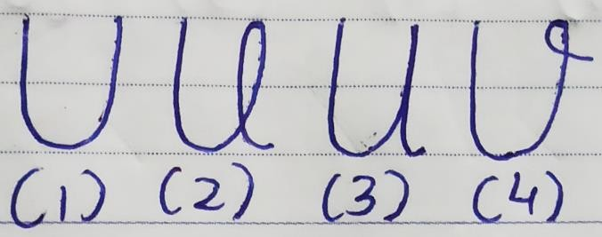

* + 1. Simple U, while creating, doing, or learning something new writers here take quick action on the sudden intuitive idea. Just like inventors they can create many new things which were not done before by anyone.
    2. Loop in U, writers having an inner loop in U don't take action on sudden intuitive ideas as they get confused. The reason they get stuck and are unable to create something unique or new easily.

3.U is written as u, they do take action yet are unable to express it fully or uniquely as they slowly take action instead of quickly taking action. Intuitive ideas don’t stay for a longer time, right?

4.Loop on the right side, now here writer adds some creativity along with quick action of the intuitive idea.

# CAPITAL V

### Formations

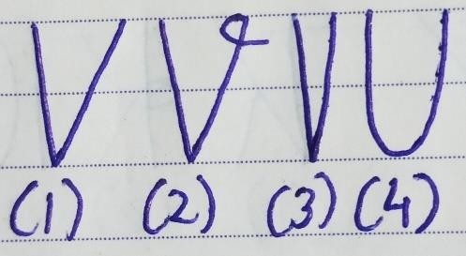

1. Normal V, they can make quick changes when it's needed as a sharp angle is present here. Eg - They are creating a new food combination & when they realize that some spices need to be added to make it perfect they quickly make that change.
2. Normal V with a loop on right, they creatively make that quick change.
3. Narrow V, they make a change in a better manner as they have critical minds due to which they don’t just make a change on assumption instead make a change based on what’s needed.
4. Letter V was written as U, people who write Letter V like U take time to make that quick change which is needed when creating, and learning something new.

CAPITAL W

### Formations

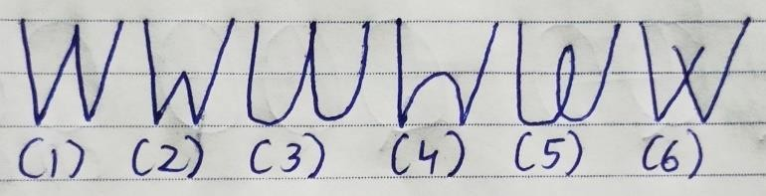

* 1. Angle W, as angles are present here these writers are very analytical when finding their learning source or teacher. These writers just want to learn no matter what so they don't care if they don't like their college or teacher or the learning source. As long as they are learning, a strict teacher or a normal quality video or book can work for them.
  2. Angle W with lower middle angle, these writers are also analytical yet they want to relate and feel an emotional connection with the teacher. Only learn when they like their clg, teacher, or the learning source.
  3. Rounded W, casual approach is there. These writers don't think much while finding their learning source or teacher. They quickly enroll in courses, buy books casually, and afterward are unable to complete them or learn from them effectively as they didn’t research about them or were analytical.
  4. Middle-rounded, they don’t know what to learn and it takes time for them to find that source since they don't have a narrow focus on exactly what type of teaching they want. They keep jumping from one source to another.
  5. Loop in middle, they follow what others are telling them to do or what others are suggesting to them to learn. Later they feel confused about why they are learning a particular topic and why they had chosen a particular learning source.
  6. Crossover, here writer keeps questioning themselves about the learning source as well as the topic they are learning about. Rare Trait.

CAPITAL X

### Formations

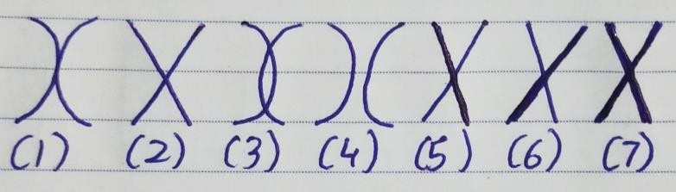

1. Rounded X, instead of questioning the writer here research to see if what they are starting is good or not. They confirm first and then start the project.
2. Angle X, writers who write X like this, do question or analyze before starting something yet they are quick. Just like the letters H, K the point at which lines meet can help you know which aspect the writer gives more importance while questioning.
3. Loop in middle rounded X, a writer here is confused. They research more than what's needed and have many questions. Fail to start things early.
4. Gap between rounded X, due to lack of judgment or lack of clarity about what to do writers here either have too many questions or no questions.
5. Angle X right side with heavy pressure, they are questioning because they can feel some temper in the future if they don’t do so.
6. Angle X left side with heavy pressure, here they are questioning because in past they felt a temper about what they had started and now don’t want to feel the same.
7. Heavy pressure, they aggressively ask a question. Temper is about both the past and the future.

CAPITAL Y

### Formations

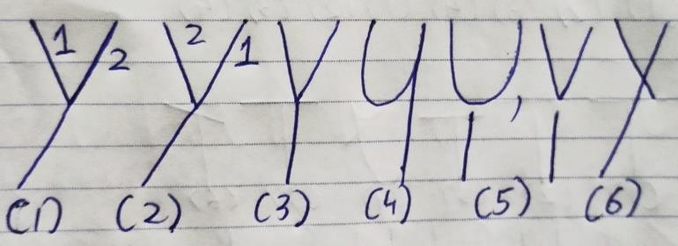

* 1. Left first, right next, do ask the writer how they write Y to find this. When starting something they had selected, they keep thinking, I must do this yet is it right? Will it work? For Eg- When starting a project they keep thinking will it make money, will it be sustainable? Do I have the skills for it? etc.
  2. Right first, left next, again ask the writer how they write. These writers have confidence due to which they ask few questions and initiate the project. For Eg- I have the skills required for this project let's create something!
  3. Font Y, these writers are more focused so they just start the project. They don't question themselves after selecting something they want to do. Eg - Let's start this business as things will work out in some way.

4.Y written in a U shape, they take a lot of time to initiate the projects as the rounded bottom is present. Rare trait.

5.Gap between V or U and stem, they ask illogical questions which are not related to what they had selected. Very rare trait.

6.Crossover, instead of questioning in a smooth, calm way they create arguments, and conflict with themselves, and others.

CAPITAL Z

### Formations

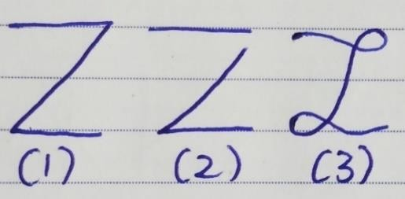

* 1. Normal Z, these are the writers who think about starting a task then focus on gut feeling to see if it's right or not & then they go for it. Analytical in nature as angles are present. For Eg- I want to do computer engineering and my gut feeling is telling me it's the right choice so I am going for it!
  2. Gap at the top, writers here have very high aspirations, and dreams. They think about starting unrealistic things and their gut feeling tells them it's not the right task to initiate yet they still do it. Very rare letter type.
  3. Loopy Z, writers here are less analytical and more casual. They just want to go with how things are going instead of taking responsibility and starting something more quickly. More creative in the process as the loop is present.